**A GROUP PROJECT REPORT**

**ON**

**‘A STUDY OF RARE BEAUTY VERSUS BOBBI BROWN’**

**SUBMITTED TO**

**DR. DEEPAL JOSHI**

**SOMLALIT INSTITUTE OF BUSINESS ADMINISTRATION**

**GUJARAT UNIVERSITY**

**AHMEDABAD CITY**

**GUJARAT STATE**

**INDIA**

**TOWARDS PARTIAL FULFILLMENT OF SEMESTER 6 REQUIREMENTS FOR**

**BACHELOR OF BUSINESS ADMINISTRATION DEGREE**

**SUBMITTED BY**

**GROUP NUMBER-6**

| **SR.NO** | **ROLL NO.** | **NAME OF THE STUDENT** |
| --- | --- | --- |
| **1** | **5** | **VIDHI RAVINDRA BAFNA** |
| **2** | **11** | **RUHEENFATEMA ZAHIRABBAS BUKHARI** |
| **3** | **13** | **PRIYANKA GOKALABHAI CHAUDHARY** |
| **4** | **46** | **TWISHA PRAVIN JAIN** |
| **5** | **56** | **LAXITA SURENDRA KHANDELWAL** |
| **6** | **58** | **NIRALI MERAMANBHAI KHUNTI** |
| **7** | **87** | **VAISHNAVI VASUDEV PANCHAL** |
| **8** | **102** | **KHUSHI SHAILESH PATEL** |
| **9** | **141** | **HEENA BHARATBHAI SOLANKI** |
| **10** | **154** | **SUHANI BRIJESH TIWARI** |

**SUBMITTED ON :-27-02- 2024**

**CERTIFICATE**

This is to certify that this project report entitled ‘A Comparison of international Beauty Brands –Bobbi Brown and Rare Beauty’ is a bonafide work of the undersigned group of students, from Somlalit Institute of BusinessAdIministration, affiliated to the Gujarat University, Ahmedabad, Gujarat state, India. This work is submitted as a semester 6 requirement for partial fulfillment of Bachelor of Business Administration (B.B.A.) degree from the Gujarat University.

| SR.NO. | ROLL NO. | NAME OF THE STUDENT | SIGNATURE |
| --- | --- | --- | --- |
| 1 | 5 | VIDHI RAVINDRA BAFNA |  |
| 2 | 11 | RUHEENFATEMA ZAHIRABBAS BUKHARI |  |
| 3 | 13 | PRIYANKA GOKALABHAI CHAUDHARY |  |
| 4 | 46 | TWISHA PRAVIN JAIN |  |
| 5 | 56 | LAXITA SURENDRA KHANDELWAL |  |
| 6 | 58 | NIRALI MERAMANBHAI KHUNTI |  |
| 7 | 87 | VAISHNAVI VASUDEV PANCHAL |  |
| 8 | 102 | KHUSHI SHAILESH PATEL |  |
| 9 | 141 | HEENA BHARATBHAI SOLANKI |  |
| 10 | 154 | SUHANI BRIJESH TIWARI |  |

___________________________ _____________________

DR. DEEPAL JOSHI EXTERNAL EVALUATOR

(PROJECT GUIDE & INSTITUE DIRECTOR)

DATE OF SUBMISSION

**ACKNOWLEDGEMENT**

“WITHOUT DATA, YOU’RE JUST ANOTHER PERSON WITH AN OPINION.”-

W. EDWARDS DEMING

Research is deep-diving into the unknown and trying to seek answers. This project report is a culmination of the research idea of our group. The successful completion of this project report would not have been possible without the sincere efforts and genuine support of many.

We take this opportunity to express our deepest gratitude towards Gujarat University for incorporating a practical studies subject in our curriculum of semester 6 BBA course. We are deeply thankful to our institute – Somlalit Institute of Business Administration (SLIBA) for giving us an opportunity to undertake this work.

We feel a deep sense of obligation towards our project guide and institute director – Dr. Deepal Joshi, for inculcating a sense of discipline and hard work among us. She guided us through the various steps of this research right from problem definition, designing research, collecting secondary and primary data to analysis of the data and deriving conclusions from our work.

We are highly thankful to the various organisations (you can name a few in particular) whose information we have used as secondary data. We are extremely grateful to our respondents who spared their time and energy to provide us with invaluable primary data for our research. Technology is a huge enabler and facilitator for research. We give immense credit to technology for its guidance and assistance in our research. We are also thankful to our group members and all our friends who directly or indirectly helped us with this mammoth work.

MEMBERS OF GROUP NUMBER:-6

SLIBA SEMESTER 6

DATE OF SUBMISSION :- 27-02-24

**PREFACE**

The business world is changing fast and evolving rapidly. The business environment is characterised as ‘VUCA’ – Volatile, Uncertain, Complex and Ambiguous. Change will be the only constant in this new business environment. As students of business management, we all will need to learn and adapt to these changes for sustainability and growth in future. To meet such upcoming challenges, the Gujarat University Bachelor in Business Administration course has introduced practical studies and research as a part of semester 6 curriculum. In accordance with that requirement, we have prepared and submitted this report.

Comparing Bobbi Brown and Rare Beauty cosmetics provides a valuable exploration of two distinct yet influential players in beauty industry. Bobbi Brown renowned for its emphasis on natural beauty and quality formulations, has long been a staple for classic, timeless makeup looks. On the other hand, Rare Beauty, founded by celebrity Selena Gomez, has rapidly gained attention for its innovative approach to inclusivity and embracing individuality. Investigating these brands allows for a comprehensive analysis of their product lines, marketing strategies, and the impact they’ve had on consumer preferences. Examining how Bobbi Brown’s traditional elegance contrasts with Rare Beauty’s contemporary ethos sheds light on the evolving dynamics within the cosmetics landscape. This research project not only offers insights into the competitive dynamics of the cosmetics market but also contributes to understanding changing beauty standards and consumer expectations.

During the first and the second year, we learnt the practical business aspects through industrial visits, preparation of project reports and viva-voce. That exercise was solo for each student. However, in the third year, we take up research projects as group of 10 students each. Therefore, this project is a learning on team work, communication, positive and negative group dynamics, as well.

‘The only source of knowledge is experience’, says Albert Einstein. Aresearch is never the end of work, it is just the beginning. We are sure this first research experience will help us undertake many more research projects in future – to contribute and add value to the body of existing knowledge and systems. We hope and pray to enrich our lives and lives of everyone around us – our family, friends, society, country and the world at large, with our ongoing research inclinations.

INDEX

| Chapter  Number | Chapter Title | Page  Number |
| --- | --- | --- |
| 1 | Introduction | 1-30 |
| 1.1 |
| 1.2 |
| 1.3 |
| 2 | Research Methodology | 31-39 |
| 2.1 Objectives of the study |
| 2.1.1 Primary Objectives |
| 2.1.2 Secondary Objectives |
| 2.2 Sources of Data |
| 2.2.1 Secondary Data |
| 2.2.2 Primary Data |
| 2.3 Sampling Method |
| 2.4 Sample Size |
| 2.5 Limitations of the study |
| 3 | Findings and Analysis | 40-65 |
| 3.1 Findings and Analysis of Secondary Objectives |
| 3.2 Findings and Analysis of Primary Objectives |
| 4 | Recommendations and Conclusion | 66-67 |
| 4.1 Recommendations |
| 4.1.1 Recommendations from Hypothesis Testing |
| 4.1.2 Recommendations from other findings of the study |
| 4.2 Conclusion |
| 5 | Bibliography and References | 68-69 |
| 6 | Annexures | 70-82  83-95 |
| 6.1 Tables |
| 6.2 A copy of Questionnaire |

**CHAPTER – 1**

**INTRODUCTION**

**A COMPARISON OF INTERNATIONAL BEAUTY BRANDS –BOBBI BROWN AND RARE BEAUTY**

**1. TREND FOR INTERNATIONAL COSMETIC IN INDIAN MARKET:**

* **HUDA BEAUTY:**

HUDA BEAUTY is a cosmetics line that was launched in 2013 by Huda Kattan. In 2017, Huda Kattan was chosen as one of "The 25 Most Influential People on the Internet" by Time, and she was listed as one of The Richest Self-Made Women and one of the Top Three beautyInfluencers by Forbes. In April 2010, Huda started a beauty blog and a YouTube channel, both called "Huda Beauty".She launched a cosmetic line named after her channel in 2013.

The Dubai-based makeup artist Huda Kattan’s brand Huda Beauty has entered the Indian market with an exclusive partnership with India’s leading beauty platform Nykaa.Nykaa is optimistic that brands like Huda beauty will help boost sales of its premium and luxury segment which currently contribute 20 percent to the company’s revenue. The Huda beauty collection will officially be available across Nykaa stores and on its online portal from January 6, 2018.

* **THE NUDE PALETTE:**

The most popular one from Huda Beauty is this versatile palette, particularly big with Indian bloggers. Stocked with 18 highly pigmented shades, ranging from just-blushed cream to ruby glitter via iridescent copper-pink, this one is great for work and play. The buttery mattes, the reflective duo-chromes, and the glitter formulas alongside the popular pressed pearl help create the softest, most dramatic looks.

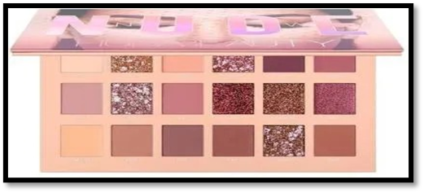

* **EASY BAKE POWDER :**

As Indians they might be a bit doubtful about foundations but a compact or loose powder is never off our list. Thanks to Kattan’s genius, they now have shades that suit Indian skin tones. Take your pick from Cupcake, Banana Bread, Cinnamon Bun, Coffee Cake, and Sugar Cookie, whose silky finishing powder is also great for sealing your foundation.

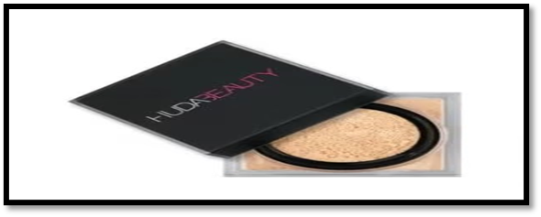

* **M.A.C:**

MAC Cosmetics, originally a Canadian company was founded in 1984 in Toronto. It was later bought by the iconic Estee Lauder Companies in 1988. MAC Cosmetics has been a market leader in global pockets for many years. However, in a country like India where many homegrown brands have really upped their game to capture the rising demand, the competition is tough for legacy brands. To break the clutter, brands are constantly innovating. Many brands are launching new and improved products, catering to specific needs rather than going with a mass strategy. MAC Cosmetics is one such brand.

* + - **M.A.C BEST SELLING PRODUCTS:**

Our best-selling, one-step powder and foundation, Studio Fix Powder Plus Foundation, wears for up to 12 hours and creates a smooth, ultra-matte finish.

Explore the best-selling M∙A∙C makeup products that made us famous, like the M∙A∙C FOUNDATION MAKEUP you made #1 – in powder and liquid formulas. STUDIO FIX FLUID SPF 15 is the ultimate multita

sking liquid foundation, with medium-to-full buildable coverage that lasts 24 hours, SPF 15 protection and an oil-controlling matte finish in 63 all-inclusive shades.

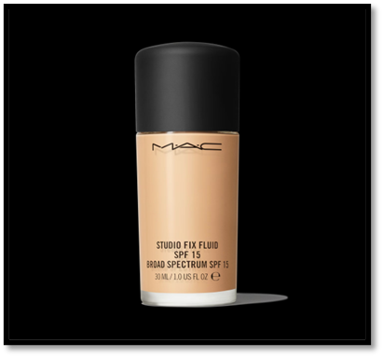

* + - **M.A.C LIPSTICK:**

M·A·C matte Lipstick – the iconic product that made M·A·C famous. This creamy rich formula features high colour payoff in a no-shine matte finish. MATTE LIPSTICK is another best-selling product from M∙A∙C, which comes in many colours ranging from neutral to bright. Apply it directly from the tube, dab it on with your fingertips or layer it on with a lip brush.

At MAC some of our most popular lipstick colours are Ruby Woo, Velvet Teddy, Mehr and Devoted to Chili. Ruby Woo is a Retro Matte, long-wearing formula that features an intense colour payoff and a completely matte finish. It'll wear for up to eight hours without feathering and is fade-proof.

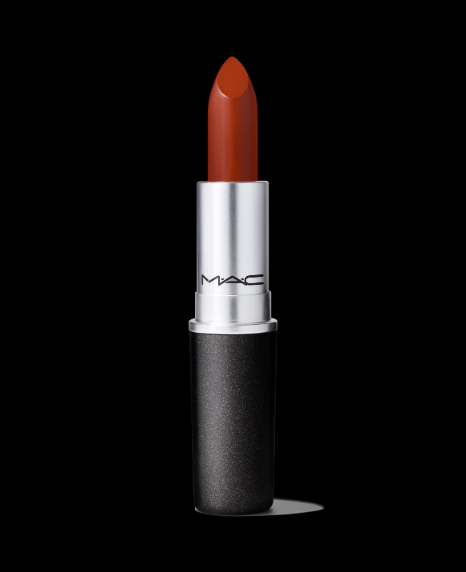

**WHY SHOULD WE CHOOSE SMASHBOX PRODUCTS?**

Smashbox products are extremely popular because of their exceptionally high quality. They are skin-friendly and offer a photo finish glow. The Smashbox makeup products offer hydrating benefits with an instant glow. They are incredibly lightweight and keep you comfortable all day long without making your skin feel cakey or heavy. Unlike products from other brands that clog the pores, Smashbox products are non-comedogenic and provide excellent results for acne-prone skin. The effects last longer – for up to 8-10 hours – without fading, smudging, and clumping. Moreover, the products are PETA certified and cruelty-free.

* **PRIMER:**

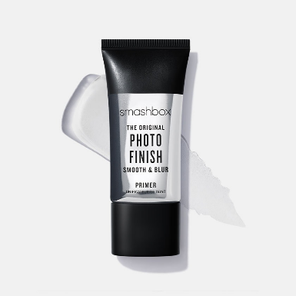

The Original Photo Finish Smooth Finish Primer by Smashbox is a holy grail that smooths your complexion by blurring fine lines, wrinkles, and enlarged pores on your skin. It makes your base blemish-free so that your makeup can work properly and stay for long hours. The product contains vitamins B, C, and E that nourish, protect, and refresh your skin. Its soft gel-like formula ensures that it stays on your face for a long time without looking patchy or cakey. This product imparts a natural shine to your face without adding any unrealistic glow.

Pros: Long-lasting, Lightweight,A little goes a long way.

Cons: Might be too matte for people with dry skin.

**BEST LONG-LASTING FOUNDATION: SMASHBOX STUDIO SKIN HYDRATING FOUNDATION:**

The Smashbox Studio Skin Hydrating Foundation blends seamlessly and covers all skin imperfections like dark circles, open pores, and redness. It is enriched with light diffusing beads, whichoffer medium to full coverage without creasing. The anti-oxidizing formula of this foundation lasts up to 15 hours. It is enriched with polymers that let your skin breathe, while hyaluronic acid nourishes it, giving a flawless, healthy look.

Pros: Long-lasting,Moisturizing,Full coverage,Vegan, Oil-free.

Cons: May feel heavy.

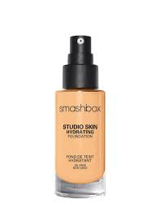

Quick Tip: Add rosewater to thin out the foundation for a natural, dewy finish.

**Too faced makeup products:**

Cover spots, signs of aging, and simply look their best by applying affordable products.If they are tired of trying out many brands that look and sound great and do not work as promised, well, they got to try the best Too Faced products. Too Faced is one brand that not only has great packaging but also does wonders to their skin with its wide range of products. Too Faced is a name that starts conversations. Whether they wear it or carry it, they are sure to grab compliments and begin to talk about it.

**1. Too Faced Better Than Sex Mascara:**

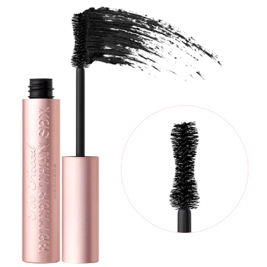

This black voluminous mascara adds volume and intensity to your eyelashes. If they have always wished for defined and multi-dimensional lashes, this is the right mascara for them! The shape of the large wand is inspired by the curves of an hourglass and the bristles are extra stiff so that the performance of the collagen-infused mascara is maximized.A single coat of the mascara is enough to get defined and full lashes, while two coats add to the curl and drama. The mascara also includes film-forming polymer that locks curls for the entire day and acacia senegal tree extract that sets the volume.

**2. Too Faced Born This Way Naturally Radiant Concealer Medium:**

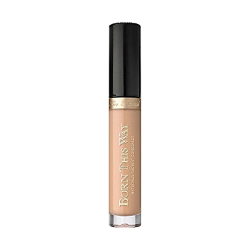

One of the best Too Faced products is The Too Faced Born This Way Naturally Radiant Concealer which helps hide imperfections instantly, makes dark circles vanish and blurs wrinkles and fine lines so that they get complete coverage that is almost undetectable. The creamy texture of the concealer makes it comfortable to wear and color correctors make the skin look flawless.

**3. Too Faced The Chocolate Bar Eye Palette:**

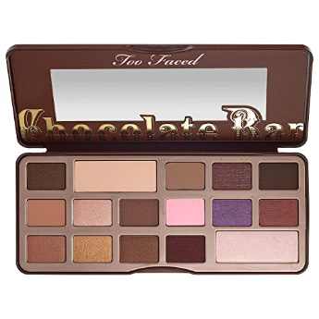

The Chocolate Bar Eye Palette by Too Faced is an absolute must have if they are a makeup junkie and chocoholic. This eye shadow palette consists of 16 shimmer and matte shadows that are scented with actual chocolate. This tempting array of sweet-smelling eye shadows is a must have if smokey or earthy makeup is their go to look. Some of the shades featured are Strawberry Bon Bon, Gilded Ganache, Hazelnut Crème Brulee and Champagne Truffle. The names are enough to get their hungry and eager to head out with a full face of fabulous makeup! This is truly one of the best chocolate themed eyeshadow palettes out there. This video will help them to understand the product better.

**WHY INTERNATIONAL COSMETIC BRAND ENTER IN INDIA?**

The number of international beauty companies entering India is likely at its highest level in a year as they aim to capitalise on the country's vast young population and rising disposable income for their upcoming growth phase.

Brands have also started a retail expansion drive, and international funds are looking for chances to invest in start-ups in the beauty industry. Executives claim that they are shifting their attention to India as a result of economic difficulties in China, which is Asia's largest market for cosmetics.

Social media influencers are leading the way towards aspirational consumerism in small cities and towns, and expanding e-commerce coverage, the demand for beauty products, from makeup and colour cosmetics to hair care and fragrances, is increasing quickly.

The biggest existing players in the Indian market are L’Oreal, Hindustan Unilever, and Colgate Palmolive. Top notch international brands like Maybelline New York, Christian Dior, Estee Lauder, Max Mara, Avon, Burberry, Bobbi Brown, Calvin Klein, etc. are interested in the raging market in India. They want to establish their stronghold beforehand in order to reap the benefits during the very early stages. The Merger and acquisitions consulting firms in India will provide proper real-time insights regarding the

existing skincare brands in India so that the international brands can take the right step to enter the market. Grow your business with the growth of the Indian economy.

Indian skin care market is expected to grow and reach $2.7 billion by 2023. Global industries are now focusing on skin products and want to leave their mark in the Indian market.

**1.1 SIGNIFICANTINTERNATIONAL COSMETIC BRANDS AVAILABLE IN STORES (OFFLINE) IN AHMEDABAD :**

* **MAYBELLINE**

Maybelline New York (formerly The Maybelline Company and Maybelline and Co., trading as Maybelline (/ˈmeɪbɪˌliːn/ MAY-bih-leen), is an American multinational cosmetics, skin care, perfume, and personal care company, based in New York City. It was founded in Chicago in 1914,and has been a subsidiary of French cosmetics company L'Oréal since 1996.

* **HISTORY**

The Maybelline Company was founded in Chicago by pharmacist Thomas Lyle Williams in 1915. Williams noticed his older sister Mabel applying a mixture of Vaseline and coal dust to her eyelashes to give them a darker, fuller look. He adapted it with a chemistry set and produced a product sold locally called Lash-Brow-Ine.

In 1967, the company was sold by Williams to Plough Inc. (now Schering-Plough) in Memphis, Tennessee. The cosmetic production facility was moved from Chicago to Memphis over one weekend. In 1975, the company moved to Little Rock, Arkansas, where it is still located. In 1990, Schering-Plough sold Maybelline to a New York investment firm, Wasserstein Perella &Co.. Maybelline's headquarters remained in Memphis until its acquisition by L'Oréal in 1996. Its headquarters was then moved to New York City in 1996and its factory to Brooklyn in 2000.

* **MAYBELLINE PRODUCTS**

Maybelline is a global cosmetics brand that offers a wide range of makeup products. Here are some of the best-selling Maybelline products:

1. Great Lash Washable Mascara: This mascara is a cult favourite and has been a best-seller for years. It is known for its volumizing formula and iconic packaging.

2. Fit Me Matte + Poreless Liquid Foundation: This foundation is popular for its lightweight, matte finish that helps to control shine and blur pores. It is available in a wide range of shades to suit different skin tones.

3. Instant Age Rewind Concealer: This concealer is a fan favourite for its ability to conceal dark circles and fine lines. It has a sponge applicator that makes it easy to apply and blend.

4. Cheek Heat Gel-Cream Blush: This blush is a gel-cream formula that blends easily and provides a natural-looking flush of colour. It has received positive reviews and is a popular choice among consumers.

5. Lash Sensational Mascara: This mascara is known for its unique fan brush that helps to separate and lengthen lashes. It is available in both washable and waterproof formulas.

* **MAC COSMETICS**

MAC Cosmetics, stylized as M·A·C, is a Canadian cosmetics manufacturer founded in Toronto in 1984 by Frank Toskan and Frank Angelo. The company is headquartered in New York City after becoming a subsidiary of Estée Lauder Companies in 1998. MAC is an acronym for Make-Up Art Cosmetics.

* **HISTORY**

In the 1990s, the brand had more than one hundred stores worldwide, earning 200 million francs. The development of the brand internationally, the opening of new points of sale, and the adaptation of product lines tailored to each continent, left little time for the founders to create new products. In 1994, the Estée Lauder Companies took control of 51% of shares of MAC Cosmetics and began managing the business end while the two founders retained creative control. In 1997, co-founder Frank Angelo died of cardiac arrest during surgery at the age of 49. Estée Lauder Inc. completed the acquisition in 1998, and Frank Toskan sold his remaining shares shortly thereafter before leaving the company at the end of the same year.

In September 2012, MAC Cosmetics launched in India firstly the "MAC Selena" collection in collaboration with the estate of Selena Quintanilla Perez. A petition on Change.org proposed the idea of this collaboration to MAC Cosmetics. Selena's sister, Suzette Quintanilla, worked with MAC to create the perfect collection that represented Selena. The collection sold out within hours not only at MAC stores, but also at other retailers that carried the collection such as Nordstrom, Bloomingdales, and Macy's. Fans stood in line for hours to get their hands on the collection while some walked away empty handed. Due to the high demand for this collection, MAC restocked the collection in December 2016. Her posthumous collaboration with MAC Cosmetics became the best-selling celebrity collection in cosmetics history.

On August 24, 2017, MAC Cosmetics announced that a collection involved with the estate of late singer Aaliyah will be made available in the summer of 2018.

In March 2022, MAC Cosmetics released their new spring Wild Cherry Collection and launched it for Japanese consumers.

* **PRODUCTS**

MAC Cosmetics is a well-known cosmetics brand that offers a wide range of makeup products. Here are some of the best-selling MAC Cosmetics products:

1. Studio Fix Fluid Foundation: This foundation is a fan favourite for its long-wearing, matte finish that provides full coverage. It is available in a wide range of shades to suit different skin tones.

2. Ruby Woo Lipstick: This iconic lipstick is a cult favourite and has been a best-seller for years. It is known for its matte finish and bright red colour.

3. Prep + Prime Fix+ Setting Spray: This setting spray is a popular choice among makeup artists and beauty enthusiasts alike. It helps to set makeup and provide a dewy finish.

4. Pro Longwear Concealer: This concealer is known for its long-wearing formula that provides full coverage and helps to conceal dark circles and blemishes. It is available in a wide range of shades to suit different skin tones.

5. Studio Fix Powder Plus Foundation: This powder foundation is a popular choice for those who prefer a matte finish. It provides buildable coverage and helps to control shine.

6. Lip Pencil: MAC Cosmetics offers a wide range of lip pencils in various shades and finishes. They are known for their long-wearing formula and ability to help prevent feathering and bleeding.

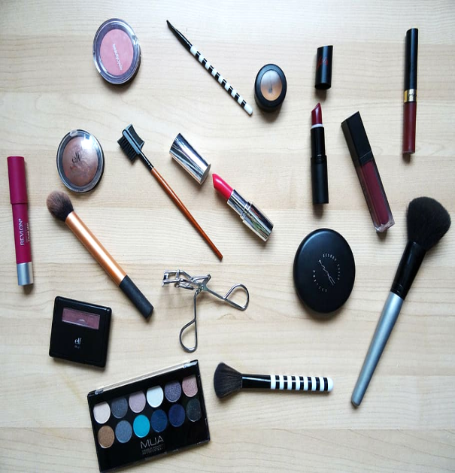

* **ORIFLAME**

Oriflame - Founded in 1967, they are a social selling beauty company in over 60 markets, with a diverse portfolio of Swedish, nature-inspired, innovative beauty and wellness products sold and marketed through approximately 3 million Oriflame Brand Partners.

* **HISTORY**

In 1967, two Swedish brothers and their friend set out to create a different kind of beauty company, one that offered new kinds of products.

In August of 2022, Oriflames Marcus Fogel (Senior Director of Global Digital Services) works alongside PayU CEO, Mario Shiliashki on working out a 21-day payment plan for buyers of Oriflames online products.

In 2023, Oriflame signed a collaboration contract with Arnest Management LLC (Arnest) a perfume, cosmetic, and household products manufacturer out of Russia. Part of the contract is that Arnest will be acquiring Cetes Cosmetics Russia.

* **PRODUCT PHILOSOPHY**

For them, beauty is a way of life - to be healthy, enjoy beautiful skin, express oneself and have fun together. At the same time, their products must be safe, reliable and deliver the results they promise.This philosophy is what guides them in creating products you can trust and fall in love with.

* **BODY SHOP**

**The Body Shop International Limited**, trading as **The Body Shop**, is a British cosmetics, skin care and perfume company.

* **HISTORY**

Founded in 1976 by Anita Roddick, the company currently has a range of 1,000 products sold in about 3,000 stores, divided between those owned by the company and franchised outlets in more than 65 countries.

Originally trading from Brighton, the company is now based in London Bridge and Littlehampton, West Sussex,[[4]](https://en.wikipedia.org/wiki/The_Body_Shop#cite_note-4) and is owned by Brazilian cosmetics company Natura as a subsidiary of the Natura & Co group. The company had been owned by the French cosmetics company L'Oréal between 2006 and 2017. In September 2017, L'Oréal sold the company to Brazilian Natura & Co for £880 million

* **L'Oréal**

In March 2006, The Body Shop agreed to a £652.3 million takeover by [L'Oréal](https://en.wikipedia.org/wiki/L%27Or%C3%A9al). The Roddicks made £130 million from the sale.

The sale caused some media controversy, particularly surrounding L'Oréal's use of animal testing. Although L'Oréal ceased animal testing itself in 1989, the company had begun selling its products in China in 1997, where the law required cosmetics to be tested on animals before sale to the public. Roddick stated that she believed the sale could allow her to be a "Trojan Horse" within the larger company, working through the Body Shop to improve its standards on animal testing and environmental issues.

* **FIRST PRODUCT**

When The Body Shop first opened its doors in 1976, it was a little green-painted shop in the streets of Brighton, England. Its approach to beauty was radically different to the big players in the beauty industry.

The Body Shop carries a wide range of products for the body, face, hair and home. The Body Shop claims its products are "inspired by nature" and feature ingredients such as [marula oil](https://en.wikipedia.org/wiki/Marula_oil) and [sesame seed oil](https://en.wikipedia.org/wiki/Sesame_oil) sourced through the Community Trade program.

**Products include:**

* Bodybutters (including [Moringa](https://en.wikipedia.org/wiki/Moringa_oleifera), [Satsuma](https://en.wikipedia.org/wiki/Satsuma_(fruit)), [Strawberry](https://en.wikipedia.org/wiki/Strawberry), [Olive](https://en.wikipedia.org/wiki/Olive), [Shea](https://en.wikipedia.org/wiki/Shea_tree), [Mango](https://en.wikipedia.org/wiki/Mango) and [Coconut](https://en.wikipedia.org/wiki/Coconut))
* Body products such as body scrub, body butter and bath lilies
* Cosmetics (including [mascara](https://en.wikipedia.org/wiki/Mascara), [lipstick](https://en.wikipedia.org/wiki/Lipstick), [lip gloss](https://en.wikipedia.org/wiki/Lip_gloss), [eye shadow](https://en.wikipedia.org/wiki/Eye_shadow) and cotton rounds)
* Full skin care ranges (including [Tea tree](https://en.wikipedia.org/wiki/Tea_tree_oil_(melaleuca_oil)), [Vitamin C](https://en.wikipedia.org/wiki/Vitamin_C), [Vitamin E](https://en.wikipedia.org/wiki/Vitamin_E), [Aloe vera](https://en.wikipedia.org/wiki/Aloe_vera) and [Seaweed](https://en.wikipedia.org/wiki/Seaweed))
* Men's skin care (Including [maca root](https://en.wikipedia.org/wiki/Maca_root) and [white musk](https://en.wikipedia.org/wiki/White_musk))
* Hair care (including their famous Banana shampoo and Banana conditioner)
* Fragrances (Women's and Men's)
* Bath products including shower gels and solid soaps
* High-end skincare range such as Oils of Life
* Face masks including sheet masks
* **BEST PRODUCTS**
* Delweiss Daily Serum Concentrate. (359)
* Camomile Sumptuous Makeup Cleansing Butter. (2353)
* Shea Body Butter. (1190)
* Vitamin E Moisture Day Cream 50ml. (1215)
* Tea Tree Skin Clearing Facial Wash. (1562)
* Vitamin C Glow Revealing Serum. (342)
* Edelweiss Smoothing Day Cream. (184)
* Hemp Hand Protector. (4785)

**1.2. RARE BEAUTY BY SELENA GOMEZ:**

**1.2.1 Classification**

* [FACE](https://sephora.nnnow.com/face-makeup)
  + [Foundation](https://sephora.nnnow.com/face-foundation)
  + [BB & CC Cream](https://sephora.nnnow.com/bb-and-cc-cream)
  + [Concealer](https://sephora.nnnow.com/face-concealer)
  + [Face Primer](https://sephora.nnnow.com/face-primer)
  + [Face Powder](https://sephora.nnnow.com/face-powder)
  + [Blush](https://sephora.nnnow.com/blush)
  + [Bronzer](https://sephora.nnnow.com/bronzer)
  + [Highlighter & Contour](https://sephora.nnnow.com/face-highlighter)
  + [Lip and Cheek Stain](https://sephora.nnnow.com/lip-and-cheek-stain)
  + [Makeup Palette](https://sephora.nnnow.com/face-palette)
* [EYE](https://sephora.nnnow.com/eye-makeup)
  + [Mascara](https://sephora.nnnow.com/eye-mascara)
  + [Eyeliner](https://sephora.nnnow.com/eyeliner)
  + [Eyeshadow](https://sephora.nnnow.com/eyeshadow)
  + [Eye Brow](https://sephora.nnnow.com/eyebrow?priority=7JEFP8431Q5--YE4GY37BIY6--S2LV9L0KYB1--SSP9GUIIPQM)
  + [Eye Primer](https://sephora.nnnow.com/eye-primer)
  + [Eye Palettes](https://sephora.nnnow.com/eye-palettes)
* [LIP](https://sephora.nnnow.com/lip-makeup)
  + [Lipstick](https://sephora.nnnow.com/lipsticks)
  + [Lip Stain](https://sephora.nnnow.com/lip-stain)
  + [Lip Gloss & Plumper](https://sephora.nnnow.com/lip-gloss)
  + [Lip Liner](https://sephora.nnnow.com/lip-liner)
  + [Lip Balm & Treatment](https://sephora.nnnow.com/lip-balm-treatments)
* [NAIL](https://sephora.nnnow.com/nail-makeup)
  + [Nail Polish](https://sephora.nnnow.com/nail-polish)
  + [Nail Tools](https://sephora.nnnow.com/nail-care)

**1.2.2** [**MAKEUP ACCESSORIES**](https://sephora.nnnow.com/makeup-accessories)

* + [Makeup Removers](https://sephora.nnnow.com/makeup-removers)
  + [Makeup Bags & Travel Cases](https://sephora.nnnow.com/makeup-bags-and-travel-cases)
  + [Makeup Setting Spray](https://sephora.nnnow.com/makeup-setting-spray)
  + [Contact Lenses](https://sephora.nnnow.com/contact-lenses)
  + [False Eyelashes](https://sephora.nnnow.com/false-eyelashes)
  + [Sponges & Applicators](https://sephora.nnnow.com/sponges-and-applicators)
  + [Makeup Brushes](https://sephora.nnnow.com/makeup-brushes)
* [MOISTURIZERS](https://sephora.nnnow.com/skin-moisturizers)
  + [Moisturizers](https://sephora.nnnow.com/skin-moisturizers)
  + [Night Creams](https://sephora.nnnow.com/night-cream)
  + [BB Cream & CC Cream](https://sephora.nnnow.com/bb-cream-and-cc-cream)
  + [Body Lotions & Oils](https://sephora.nnnow.com/body-lotions-oils)
  + [Hand and Foot Cream](https://sephora.nnnow.com/hand-cream-and-foot-cream)
* [CLEANSERS](https://sephora.nnnow.com/cleansers)
  + [Face Wash & Cleansers](https://sephora.nnnow.com/face-wash-and-cleansers)
  + [Makeup Removers](https://sephora.nnnow.com/makeup-removers?priority=PAHPEGEPVYX--E0ANC9EFYPI--3ES4NFTT5P0--57N4O99OLPW)
  + [Face Wipes](https://sephora.nnnow.com/face-wipes)
  + [Body Scrub & Exfoliants](https://sephora.nnnow.com/body-scrub-and-exfoliants)
  + [Toners](https://sephora.nnnow.com/toners)
  + [Face Mists](https://sephora.nnnow.com/face-mists)
* 8[TOOLS & TREATMENTS](https://sephora.nnnow.com/sephora-skincare-hightechtools)
  + [Face Serum & Treatments](https://sephora.nnnow.com/face-serums)
  + [Lip Balm & Treatments](https://sephora.nnnow.com/lip-balm-and-treatment)
  + [Eye Creams & Treatments](https://sephora.nnnow.com/eye-creams-and-treatments)
  + [Sunscreen](https://sephora.nnnow.com/sunscreen)
  + [Face Tools](https://sephora.nnnow.com/face-tools)
* 3.1.9[MASKS](https://sephora.nnnow.com/masks)
  + [Face Masks](https://sephora.nnnow.com/face-masks)
  + [Sheet Masks](https://sephora.nnnow.com/sheet-masks)
  + [Eye Masks](https://sephora.nnnow.com/eye-masks)
  + [Nose Masks & Strips](https://sephora.nnnow.com/nose-masks-and-strips)
  + [Lip Masks](https://sephora.nnnow.com/lip-masks)
  + [Hand Masks](https://sephora.nnnow.com/hand-masks)
  + [Foot Masks](https://sephora.nnnow.com/foot-masks)

**1.3 BOBBI BROWN**

**Classification**

**MAKEUP**

* FACE

Foundation

1. Natural

* + Nude Finish Tined Moisturizer SPF 15
  + Skin Foundation
  + Skin Foundation SPF15

2. Radiant

* + Radiant Intensive Skin Foundation SPF

3. Matte

* + Skin Long-Wear Fluid Powder Foundation SPF 20
  + Skin Weightless Foundation SPF 15
  + Skin Weightless Powder Foundation

Corrector and Concealer

1. Natural
   * Intensive Skin Serum Concealer
2. Radiant
   * Creamy Concealer Kit
3. Matte
   * Instant Full Coverage Concealer

* LIP
* Lipstick
* Crushed Lip Color
* Luxe Lip Color
* Lip Color
* Luxe Matte Lip Color
* Luxe Shine Intense Lipstick
* Lip Balm & Tints
* Pot Rouge For Lips & Cheeks
* Extra Lip Tint
* Crushed Liquid Li
* Lip Balm SPF 15
* Lip Gloss
* Crushed Oil Infused Gloss
* Lip Liner
* EYE
* Eyeliner/Kajal
* Mascara
* Eye Shadow
* Powdereye Shadow
* Cream Eye Shadow
* Eye Shadow Palettes
* Brow
* CHEEK
* Highlight & Glow
* Extra Illuminating Moisture Balm
* Nude Finish Illuminating Powder
* Highlighting Powder
* Blush
* Shimmer Bricks
* Bronzer
* Brightening Brick
* Illuminating Bronzing Powder
* **MORE**
* Sets & Palettes
* Extra Lip Tint Duo
* Vitamin Moisture Set
* Celebrate Lashes Mascara Set
* Out All Night Mini Long – Wear Cream
* Bare Nudes Eye Shadow Palette
* Mini Crushed Lip Trio – Festive Ready
* The Gateway Skincare Set
* Radiance Bosst Essentials Set
* Real Nudes Eye Shadow Palette
* Bobbi Brown Four Ways Kit
* Luxe Eye & Cheek Palette
* Brushed & Tools
* Concealer Blending Brush
* Powder Brush
* Angled Face Brush
* Sheer Powder Brush
* Face Blender Brush
* Full Coverage Face Brush
* Foundation Brush
* SKINCARE
* Vitamin Enriched Face Base
* Moisturizer
* Hydrating Water Fresh Cream
* Hydrating Face cream
* Extra Repair Moisture Cream
* Serums & Treatments
* Extra Repair Serum
* Extra Face Oil
* Skin Clarifier
* Skin Reviver
* Cleansers and Toner
* Soothing Cleansing Oil
* Makeup Melter Cleanser
* Hydrating Face Tonic
* Eye & Lip Care
* Hydrating Eye Cream
* Extra Eye Repair Cream
* SPF
* Primer Plus Protection SPF 50
* MINI BAR
* Mini Vitamin Enriched Face Base
* Mini Crushed Lip Color
* Mini Skin Long-Wear Weightless Foundation

**1.4. HISTORY OF BOBBI BROWN:**

Bobbi Brown Cosmetics is a well-known makeup brand that was founded by makeup artist Bobbi Brown in 1991. She started the company with a mission to create makeup that enhances natural beauty and suits all skin tones. The brand gained popularity for its high-quality products, neutral shades, and focus on a natural, fresh look.

In the early years, the brand gained recognition for its signature product, the “Bobbi Brown 10-Step Makeup Lesson,” which emphasized a simple and effortless approach to makeup application. The company expanded rapidly and became a favorite among makeup enthusiasts and professionals alike.

Bobbi Brown Cosmetics continued to grow and gained international success. In 1995, Estée Lauder Companies acquired the brand, allowing it to further expand its reach and product offerings.

**1.4.1 KEY DEVELOPMENTS IN THE HISTORY OF BOBBI BROWN COSMETICS :**

* Founding and Early Success: Bobbi Brown founded her eponymous cosmetics brand in 1991, focusing on natural beauty and enhancing individual features. The brand quickly gained popularity and recognition for its simple and inclusive approach to makeup.
* Acquisition by Estée Lauder: In 1995, Estée Lauder Companies acquired Bobbi Brown Cosmetics, which provided the brand with greater resources and opportunities for expansion.
* Global Expansion: After the acquisition, Bobbi Brown Cosmetics expanded its reach globally, establishing a strong presence in various countries and becoming a beloved brand worldwide.
* Broadening Product Offerings: Over the years, the brand introduced a wide range of makeup products, skincare, and fragrance lines. Some iconic products include the Bobbi Brown Foundation Stick, Bobbi Brown Shimmer Brick, and the Long-Wear Gel Eyeliner.
* Commitment to Inclusivity: Bobbi Brown Cosmetics has been known for its commitment to inclusivity, offering makeup products that cater to various skin tones and celebrating diversity.

**1.4.2 BOBBI BROWN COSMETICS OFFERED A WIDE RANGE OF MAKEUP AND SKINCARE PRODUCTS. HERE ARE SOME OF THE PRODUCTS THAT ARE AVAILABLE:**

* Foundation: Bobbi Brown offered various foundation formulas, including the Skin Long-Wear Weightless Foundation, Skin Foundation Stick, and Intensive Skin Serum Foundation.
* Concealer: The brand had a selection of concealers, such as the Instant Full Cover Concealer and Creamy Concealer Kit.
* Lipstick: Bobbi Brown had a diverse range of lip products, including the Luxe Lip Color, Crushed Lip Color, and Nourishing Lip Color.
* Eyeshadow: The eyeshadow range included both individual eyeshadows and eyeshadow palettes, such as the Luxe Eyeshadow Singles and the Eye Shadow Palette.
* Mascara: Bobbi Brown offered different mascaras, like the Smokey Eye Mascara and No Smudge Mascara.
* Blush and Bronzer: The brand had blush options like the Pot Rouge for Lips & Cheeks and the Blush Duo. For bronzing, they offered products like the Bronzing Powder and Illuminating Bronzing Powder.
* Skincare: Bobbi Brown also had a line of skincare products, such as moisturizers, serums, and cleansers, tailored to various skin types.
* Brushes and Tools: The brand offered a wide selection of makeup brushes and tools to aid in flawless application.

**1.4.3 PRICING OF BOBBI BROWN COSMETIC PRODUCTS:**

The pricing of products from Bobbi Brown Cosmetics varied based on the specific product category and formulation. Bobbi Brown is considered a high-end cosmetics brand, and its pricing generally reflects the quality and reputation of its products. Here are some general price ranges for some of their popular products:

1. Foundation: The prices for foundations ranged from around 3000/- to 5000/-, depending on the formulation and product size.
2. Concealer: Concealers were priced between 2400/- to 4000/-, depending on the type and packaging.
3. Lipstick: Lip products like lipsticks were typically priced around 2000/- to 3500/-.
4. Eyeshadow: Individual eyeshadows were generally priced around 2000/- to 2500/-, while eyeshadow palettes could range from $40 to $70 or more.
5. Mascara: Bobbi Brown mascara prices were typically in the range of 2000/- to 2500/-.
6. Blush and Bronzer: Blushes and bronzers were priced around $30 to $50, depending on the product type and size.
7. Skincare: Prices for skincare products varied widely based on the type of product and its ingredients, ranging from around 1600/- to over 8200/-.

**Bobbi Brown Cosmetics employed various marketing and distribution strategies to promote and sell their products. Here are some of the common strategies they utilized:**

Marketing Strategies:

1. Natural Beauty and Inclusivity: Bobbi Brown's marketing message revolved around the concept of natural beauty and enhancing individual features. They celebrated diversity and inclusivity by offering makeup products suitable for a wide range of skin tones.

2. Celebrity Endorsements: The brand occasionally collaborated with celebrities and influencers to promote their products, leveraging their popularity and influence to reach a broader audience.

3. Social Media Marketing: Bobbi Brown Cosmetics actively engaged with their audience on social media platforms such as Instagram, Facebook, Twitter, and YouTube. They shared makeup tutorials, product launches, and user-generated content to connect with customers and build brand loyalty.

4. Content Marketing: The brand focused on creating valuable content through blog posts, video tutorials, and beauty tips, establishing themselves as an authority in the beauty industry.

5. In-Store Events: Bobbi Brown Cosmetics often hosted in-store events and makeup demonstrations to provide personalized experiences for customers and showcase their products.

6. Collaborations and Limited Editions: The brand occasionally collaborated with other brands or artists to create limited-edition product collections, generating excitement and interest among their customer base.

**DISTRIBUTION STRATEGIES** :-

1. Retail Partnerships: Bobbi Brown products were available through various retail partners, such as department stores, specialty beauty retailers, and cosmetic boutiques.

2. Online Presence: The brand had its official e-commerce website, allowing customers to purchase products directly online. They offered a user-friendly online shopping experience and often provided exclusive online promotions and offers.

3. International Expansion: Bobbi Brown Cosmetics expanded its distribution to reach customers in different countries, partnering with local retailers or opening standalone stores in key markets.

4. Travel Retail: The brand also had a presence in travel retail locations, like airports, to target global travelers.

5. Bobbi Brown Studios and Counters: Bobbi Brown Studios and beauty counters were set up in various cities, providing customers with the opportunity to receive personalized makeup consultations and try out products.

**1.5 .HISTORY OF RARE BEAUTY COSMETICS:**

Rare Beauty was founded on February 22, 2019, by American singer and actress Selena Gomez. On February 4, 2020, she formally announced her company on social media. In its accompanying video, Gomez revealed that she had been working on the cosmetics line for the last two years and that she had “found the right partners and the right team – we now have 28 amazing people that are working for the brand.” On the new venture, Gomez explained that Rare Beauty would encompass an entire lifestyle and that it “isn’t about how other people see you – it’s about how you see yourself. I want us all to stop comparing ourselves to each other and to start embracing our uniqueness. You are not defined by a photo, a like, or a comment.” In an interview with Allure, Gomez stated that “beauty doesn’t have to be defined by a like or a comment, or your body. We were always under the notion that this would also be about mental health and creating a safe place for people to connect.”

She also emphasized that her “main purpose when I started Rare Beauty was to break down the unrealistic standards of beauty we see in society today,” motivated by the “pressure on us to be perfect.”

**1.5.1 DEVELOPMENT OF RARE BEAUTY COSMETICS:**

In August 2020, Gomez revealed on Instagram that Rare Beauty would be launching on September 3 on its official website and in Sephora stores across North America. Its original included 48 shades of foundation, matte lip creams, eyebrow definers, liquid blush, and lip balms. The cruelty-free and vegan products were packaged with recyclable materials certified by the Forest Stewardship Council (FSC), and was printed with water- based ink. As the company grew, Rare Beauty expanded its markets to the Middle East, Europe, and Southeast Asia. In February 2022, the company launched in the United Kingdom exclusively through Space.NK. Going viral on TikTok, the Rare Beauty blush has made a significant impact on the brands imaging, some even say the product is “too pigmented.”

As part of her commitment to mental health awareness and education, Gomez created the Rare Impact Fund to help “young people gain access to mental health resources” and is committed to raising US$100 million over the next ten years. To achieve that goal, a percentage of all Rare Beauty sales, along with “philanthropic foundations, corporate partners, and individuals in our community” will be donated towards the fund. In its first year, the non-profit affiliate provided $1.2 million in grants to eight mental health and education- focused organizations, including the YaleCenter for Emotional Intelligence and Didi Hirsch Mental Health Services. For Mental Health Awareness Month, Rare Beauty launched its first GoFundMe campaign and pledged to match $200,000 of donations.

**1.5.2 PRODUCT RANGE OF RARE BEAUTY COSMETICS:**

Rare Beauty sells makeup products for the face, lips, and eyes. Some items are blush (cream and liquid), lipstick (liquid, cream, gloss, and balm), foundation, concealer, liquid eyeliner, and highlighter. They also sell tools such as makeup brushes, mirrors, and a sponge. In total, they have over 200 products. It goes without saying that having products for every step of a makeup routine is necessary to show consumers they can get all their needs from one brand, which increases brand loyalty. For Rare Beauty, their aim with their products is to have them be Lightweight and breathable but also Still buildable. With that said, people Who prefer a more natural look tend to Love Rare Beauty products.

**1.5.2.1 StayVulnerableMeltingCreamBlush:**

Among their 200 products, their blushes are their most loved products. Allure, an American women’s beauty magazine, awarded Rare Beauty a Best of Beauty Award for the brand’s Stay Vulnerable Melting Cream Blush.

The reason why consumers love the Stay Vulnerable Melting Cream Blush is because it is true to its name; it easily melts into the skin. It also comes in five different shades that actually show up on darker skin tones. Rare Beauty values creating shades that cater to a wide range of skin tones.

**1.5.2.2 Liquid touch weightless foundation & Liquid Touch Brighting concealer.**

Rare Beauty has 48 shades of their Liquid Touch Weightless Foundation and the same 48 shades for their Liquid Touch Brightening Concealer. The shades are split into 6 different categories: Light, Light-Med, Medium, Medium-Tan, Med-Deep, and Deep. Within these categories, there are 8 shades that cater to different skin colors and undertones. Having a wide range of colors, shades, and Undertones when it becomes to face base products is starting to become the norm for new beauty brands because it shows that the brand wants to have a diverse audience and values spending the extra money to make many shade

**1.5.3 PRICING STRATEGY OF RARE BEAUTY COSMETICS:**

Prices for Rare Beauty’s makeup products range from $14-$29. They are more expensive compared to drugstore makeup brands but cheaper than luxury brands. They are in line with their celebrity competitors. Ariana Grande’s r.e.m. beauty ranges from $15-$24, and Rihanna’s Fenty Beauty ranges from $20-$39. Overall, Rare Beauty is pretty affordable, which consumers love.

**1.5.4 MARKETING STRATEGY OF RARE BEAUTY COSMETICS**

**1.5.4.1 SELENA GOMEZ AS THE FACE OF THE BRAND**

Selena Gomez does a lot of promotion for her brand as her face alone will attract people’s attention. She promotes Rare Beauty by posting about the brand on her social media accounts. Her Instagram account is where she first announced the new venture. On February 4, 2020, she posted a video of the behind-the- scenes process of her creating Rare Beauty. The video garnered over 8 million views and over 1.8 million likes. When the brand has exciting News to share like its launch, the release of new products, and its arrival to Space NK in the UK, Selena Gomez makes announcement posts for her 300 million Instagram followers to see.

Selena Gomez is featured in a lot of posts for Rare Beauty’s social media accounts. On Rare Beauty’s Instagram account, where they have 3 million followers, they posted a behind-the- scenes photo of Selena Gomez in her look for the 2022 Screen Actors Guild Awards. In the caption, they wrote and linked all of the Rare Beauty products Selena Gomez used as part of her makeup look. In doing this, consumers can buy and recreate Selena Gomez’s exact SAG Awards makeup look down to the shades of each product. They can also buy the products through Instagram’s shopping feature, so they don’t even have to leave the app.

Consumers can see how much Selena Gomez loves her products through her using and talking about them. She has made multiple “Get Ready with Me” videos for Rare Beauty’s Youtube channel where she shows her doing her entire makeup routine only using Rare Beauty products. Selena Gomez also uses Rare Beauty on other Youtube channels. She’s filmed an Everyday Spring Makeup Routine for Sephora and a Guide to the Perfect Cat Eye for Vogue. When asked what her favorite products are, she answers with the Soft Pinch Liquid Blush, Liquid Touch Brightening Concealer, Positive Strokes Universal Volumizing Mascara, Positive Strokes Matte Liquid Liner, and Stay Vulnerable Glossy Lip Balm. Fans want to have and use exactly what their favorite celebrity uses, so by Selena showing what she uses, she drives sales.

**1.5.5 DISTRIBUTION STRATEGY OF RARE BEAUTY COSMETICS:**

**1.5.5.1 A WORLDWIDE BRAND**

Rare Beauty was first launched in North America on September 3, 2020. It wasn’t until the summer of 2021 that the brand expanded into select countries in Europe, the Middle East, and Asia Pacific. Selena Gomez has a large global fanbase, so having her brand’s products be available worldwide is important in not making consumers feel left out and in increasing sales. The brand is expected to continue expanding into other countries and regions in the future.

**1.5.5.2 SEPHORA**

The products are sold exclusively at Sephora (in stores and online) and on the Rare Beauty website. Getting sold at a store is crucial to makeup brands because consumers want to physically see and test the makeup to make sure it is something they will like and use. This process is difficult to do through a screen, so makeup users tend to be more cautious when buying makeup online or completely avoid doing so. Rare Beauty has made it easy for consumers to test them out in person by being available in Sephora.

Sephora is one of the largest multi- brand retailers in the world with over 2,000 stores in 35 countries. As many people go to Sephora to buy makeup, Rare Beauty has increased visibility that they wouldn’t get from only being sold online.

**1.6 .SUMMARY OF RESEARCH PAPERS:**

**1.6.1 RARE BEAUTY**

The research are tried to identify the meaning of beauty in rare beauty video advertisement The researchers used theory of meaning proposed by Barthes (1967) to identify the meaning of beauty in Rare Beauty video advertisement.

The researchers found three meaning of beauty in Rare Beauty Video Advertisement.

The first meaning of beauty is everyone is beautiful with their own uniqueness and there is no the researchers are tried to identify the meaning of beauty in Rare Beauty video advertisement.

The data were analyzed with descriptive qualitative method. The researchers used theory of meaning proposed by Barthes such a standard to consider as beauty.

The second meaning of beauty is when the women are confident in expressing their beauty they will be happy.

This article discusses the influence of advertising and popular culture on the formation of an ideological identity of one's beauty and good looks in online media. The influence of the myth of feminism and masculinity on oneself and the environment, and critical attitudes towards advertising in online media.However, the online media also displays various advertisements that become channels to build a world image such as beauty and good looks. For example, a skincare ad that constructs the idea that beautiful women are white, glowing,(athletic).

The purpose of this article is to see how advertising in online media can shape the ideological identity of a person's beauty andgood looks. This article uses a qualitative research method of literature study. The data sources in this article are data from various research references such as scientific journals, e-books, as well as other relevant and credible information data sources.

The results of this article state that advertising and popular culture greatly affect the mindset of both male and female consumers.

Advertising constructs a mindset towards a product as if the product displayed is real, causing people to set standards for a person's beauty and good looks based on their physical appearance. However, we must be able to be critical of the spread of information.

References

N W Alan Mirani, K D Puspita C, D P Eka Pratiwi. Journal of Humanities, Social Science, Public

Administration and Management (HUSOCPUMENT ) 1 (2), 38-44, 2021

**1.7. SUMMARY OF RESEARCH PAPERS:**

**1.7.1 BOBBI BROWN**

In today's highly competitive and oversaturated market, companies are constantly striving to distinguish themselves and make an impact on consumers’ mind. Research has shown that brands with a strong and clear brand identity are more likely to succeed in connecting with consumers.

The present study aims to investigate how founder characteristics can affect brand identity and influence consumer behavior towards brands, as well as the impact of consumer nationality on this relationship.

The research is conducted through a case study of Bobbi Brown Cosmetics (BBC) and Jones Road Beauty (JRB), two makeup brands founded by makeup artist Bobbi Brown (BB).

Cosmetic consumers were found to be very loyal to they preferred brand making it critical for companies to make a strong impression on consumers from the outset of their decision-making process.

BBC is widely available around the world, and in Portugal, it can be purchased in stores such as Sephora (both physical and online) and Lookfantastic (online), as well as at the brand store located in the El Corte-Inglés department store in Lisbon.

When it comes to the USA, BBC is even easier to find. Customers can shop BBC at their local department store, online, or in its own brand locations.

This allows customers to feel that they are investing in the brand's skills and expertise, and that the products will help them achieve similar expertise as makeup artists.

BBC also provides online resources, including videos, individual appointments with makeup artists, live sessions, a chatbot for instant consultation, and a virtual try-on feature, for those unable to visit stores in person.

This shared philosophy with BB's previous brand helped to have a spillover effect and many loyal consumers who followed BB’s journey and identify with her thoughts on makeup are also accompany this new adventure.

As the entrepreneur is launching a new concept in the beauty industry many new consumers are curious about the brand.

References:

Ramya, N., & Ali, D. S. M. (2016a). Factors affecting consumer buying behavior. International Journal of Applied Research, 2(10), 76–80.

**INTERNATIONAL COSMETICS BRAND AVAILABLE IN INDIA**

The growth of the luxury market has been phenomenal in recent years, especially in the emerging markets such as India. This research studied luxury value aspects (personal and social) of luxury cosmetic brands and their impact on consumer attitudes and usage behavior, with a focus on women consumers.

Hence the symbolic and psychological traits among consumer will show their willingness to buy and preferences on luxury cosmetic brands.

The findings of this study provide valuable insights to marketers and managers to understand consumer trends, attitudes and behavior in the luxury cosmetic market and develop marketing strategies to successfully market their products.

Nevertheless, while other countries of the world use the traditional Indian products made of herbs and ayurvedic as beautification solutions, more an more Indian 679 consumers consider the international brands of personal care, products that improve the way of life, being convinced that their association, like individuals, with the use of these successful international brands, represents the symbol of the superior, sophisticated class.

International names like Huda Beauty, lOreal, Lakme, Mamaearth and among others, win more and more prestige among the consumers in the key cities, like Mumbai and Hyderabad.

Along with the development of the Indian en-gross trade, these premium brands offer various types being supported by a well sustantiated marketing activity.

The opening of the Indian economy, the acceptance of this country as a member of the International Trade Organization, made India a productive and efficient market for the international cosmetics. The West India remains the biggest outlet of cosmetics in the country, relying on the increasing level of awareness of the products by the consumers, on lower prices on a competitive market and on bigger personal incomes, and also on the desire to spend more for obtaining some registered mark products.

**CHAPTER – 2**

**RESEARCH METHODOLOGY**

**2.1 Objectives of the study**

**2.1.1 Primary objectives**

This research contains two hypothesis :

1. One-way ANOVA
2. Chi-Square test of association

The hypothesis is a prediction of a relationship between one or more variables and the problem under study. That is, it specifies the relationship among variables .These variables are to be statistically tested at a later stage. Hypotheses are scientifically reasonable predictions.

**First hypothesis : ONE-WAY ANOVA**

The purpose of a one-way ANOVA test is to determine the existence of a statistically significant difference among several group means. The test actually uses variances to help determine if the means are equal or not. In order to perform a one-way ANOVA test, there are five basic **as**sumptions to be fulfilled:

1. Each population from which a sample is taken is assumed to be normal.
2. All samples are randomly selected and independent.
3. The populations are assumed to have equalstandard deviations (or variances).
4. The factor is a categorical variable.
5. The response is a numerical variable

Objectives:

* To find the correlation between the factors and income using ONE WAY ANOVA.

The study has been carried out in order to find the correlation between the factors that influence the consumer’s behavior towards cosmetic products and income

* In a one way ANOVA there are two possible hypotheses.

The null hypothesis (H0) is that there is no difference between the groups and equality between means

The alternative hypothesis (H1) is that there is a difference between the means and groups.

**Second Hypothesis : CHI-SQUARE TEST OF ASSOCIATION**

The chi-square test is a hypothesis test designed to test for a statistically significant relationship between nominal and ordinal variables organized in a bivariate table.

In other words, it tells us whether two variables are independent of one another.

Objectives:

* To determine if the difference between observed data and expected data is due to chance, or if it is due to a relationship between the variables .
* It is used to test the goodness of fit
* A Chi-sqaure test is a statistical test used to compare observed values with expected values.
* In Chi-Square test there are two possible hypotheses.

The null hypothesis (H0) is that there is no significance association between familiarity with beauty brands Rare Beauty and Bobbi Brown and the age of respondants.

The alternative hypothesis (H1) is that there is significant association between familiarity with beauty brands Rare Beauty and Bobbi Brown and the age of respondants.

**2.1.2 Secondary objectives**

1. Are you familiar with beauty brands Rare Beauty and Bobbi Brown?

Objective : To study the awareness among the consumers on cosmetics brands Rare Beauty and Bobbi Brown.

1. Do you use cosmetics from Bobbi Brown and/or Rare Beauty?

Objective : To know that whether the consumers use both or either of this cosmetic brands or not.

**For Users of Rare Beauty and or Bobbi Brown**

1. Have you used beauty products from Rare Beauty and Bobbi Brown?

Objective : To find out if the consumer have used any of the products of brands Rare beauty and Bobbi brown.

2. Which brand do you prefer for makeup products?

Objective : To know the brand preferences of consumer relating to cosmetic products.

3. Which brand products do you think have a longer-lasting effect and better performance?

Objective : To analyze the satisfaction of consumers in cosmetic brands Rare Beauty and Bobbi Brown.

4. Which brand products are more affordable?

Objective : To gain knowledge about the affordability of the brands among its consumers.

5. Is Bobbi Brown foundation better than Rare Beauty?

Objective : To understand the product difference between the two brands Rare Beauty and Bobbi Brown and to get the knowledge about the quality and the betterment of particular product.

1. Rare Beauty lipstick long lasting than Bobbi Brown?

Objective : To understand consumers beauty needs , and which brand product they like the most.

7. Do these two brands have Sun Protection Factor in their products?

Objective : To gain knowledge about the sun protection factor present in the products of this brands.

8. Which brand products are waterproof, sweatproof and transfer resistant?

Objective : To find out which brand among Rare Beauty and Bobbi Brown are waterproof, sweatproof and transfer resistant and have the better quality or quantity.

9. What is the most selling product from these two brands?

Objective : To identify the top product of the both brands which is loved most by the consumers

10. If price were not a consideration, how likely or unlikely are you to purchase products from these brands?

Objective : To understand that what aspire the consumer to go for the brand without considering the price factors.

11. Which brand products are you more likely to use in the future?

Objective : To study the brand loyalty among its consumers and will they will stick with the brand in future.

12. What would be the main factor influencing your choice of future product usage?

Objective : To identify the factors affecting (factors such as packaging, price quality, etc.) buyer’s decision for choosing the cosmetic products.

13. Which specific type of product are you more likely to consider for future usage from your preferred brand?

Objective : To identify the consumers most preferred product from their preferred brand which they will stick loyal in future also.

14. If you were to purchase a product within the next month, which brand would you lean towards?

Objective : To find out the most preferred brand among consumers.

15. If you choose a preferred brand for future usage, what influenced your decision the most?

Objective : To analyze what aspire consumer to go for the brand such as brand ethics and values, recommendation from influencers and friends, online reviews and rating, or in store experience

16. What beauty products are you willing to buy at high prices?

Objective : to find out the most preferred brand of cosmetic products ever after increases in prices of the products.

17. What changes would you like to see in both Rare beauty & Bobbi brown products?

Objective : To understand the consumers needs and preferences and to get their feedbacks such as better packaging ,product range, etc for the betterment of the products.

**For Non-users of Rare Beauty and Bobbi Brown**

1. Do you use any other Cosmetic brand?

Objective : To study how much percentage of people doesn’t use Rare Beauty and Bobbi Brown.

2. Which Cosmetics brands you are using other than Rare Beauty and Bobbi Brown?

Objective :Tto find out the top brand of cosmetic products other than the Rare Beauty and Bobbi Brown.

3. From where do you prefer to buy these Cosmetics?

Objectives : To find out the most preferred place of purchasing a cosmetic product by cosmetic consumers.

4. What type of cosmetics products you prefer to purchase?

Objective : To find out what majority of ayurvedic or chemical brands are used among various consumers.

5. Do you prefer international products more than local products?

Objective : To analyze whether the consumers lean more towards local products or international products.

6. Would you like to continue your current brands even if there is increase in 10-15% or above in price?

Objective : To identify whether the consumers loyalty towards their brand despite of hike in price of the products.

7. Reasons for not using Bobbi Brown Cosmetics?

Objective : To understand what makes the consumer not allow to buy the Bobbi Brown cosmetics.

8. What can be a reason for not choosing Rare Beauty Cosmetics?

Objective : To understand what makes the consumer not allow to buy Rare Beauty cosmetics.

9. Can you share any alternatives that you prefer over Bobbi Brown or Rare Beauty?

Objective : To find out if there is any other brand which the consumer prefer as an alternative of these brands.

10. Would you reconsider using Bobbi Brown or Rare Beauty cosmetics in the future?

Objective : To know whether the consumer will stick towards the brands in future.

11. Have your friends or family members shared their opinions or experiences with Bobbi Brown and Rare Beauty brands that influence your choice?

Objective : To study about the positive and negative experiences or opinions from the friends or family members that influence the consumer choice about the brands.

12. Have you ever had any experiences, positive or negative, with Bobbi Brown or Rare Beauty Cosmetics that influenced your decisions?

Objective : To study about the positive or negative experience the individual had that influenced his/her decision for buying the products.

2.2.1 Secondary Data (Internet, books, magazines)

Secondary data is collected from internet, books, magazines etc. A detailed list of sources of secondary data is mentioned in Chapter 5, Page number:-69

2.2.2 Primary Data

-Research instrument a structured undisguised questionnaire

(A copy of questionnaire is attached in chapter 6, Annexure 2, page number 84-100)

-Population-Ahmedabad city in October - November 2023 or whatever is your population of study.

-Sampling element - an individual who use Rare beauty & bobbi brown beauty product.

* 1. **Sampling Method**

**Judgment Sampling**

It is a type of non random sampling method used in survey research and data collection . it is a method in which the sample is selected based on the researchers judgment.

This method is different from random sampling,which is a method of selecting a sample in which each member of the population has an equal chance of being selected.

**Why We Have Used Judgment Sampling?**

1. We have used this because population of intetest was rare and hard to find who uses cosmetic products of rare beauty and bobbi brown.
2. It also saves our time and money when compared to broader sampling method.

**Use Of Google Forms For Primary Data Collection**

1. It helped us a lot because it is a free application where users can create their own surveys and collect responses,
2. We can add questions , set pictures and even upload pictures to help answer question.
3. It is also accessible anywhere ,automatically collect responses and even add advance features like conditional logic.

Hence in this way it has helped us.

**2.4 Sample Size**

The sample size was 200 .

We have to survey from 200 females who were from elite class

* 1. **Limitations Of The Study**

1) It was time consuming because we have to focus on only females and in that also rich income women were targeted because cosmectics products (RARE BESUTY AND BOBBI BROWN) were high in price.

2) Another limitations is that it may have happened that some of the respondantshave given wrong information.

3) Some females have declined to fill the google form because they don’t want to disclose their personal details like mobile number,emailid,incomeetc

4) One more limitation is that the resulting conclusions cannot be extrapolated statistically to the population.

5) It may lead to wrong conclusions because we have done survey of only 200 respondants.

6) It also created a feeling of discrimation within the population .

Hence these were the limitations of study.

**CHAPTER – 3**

**FINDINGS AND ANALYSIS**

**3.1 Findings and Analysis of Secondary Objectives:**

3.1.1. Email

There is no graph for the corresponding data because it is an open-

ended question.

3.1.2. Are you familiar with beauty brands Rare Beauty and Bobbi Brown?

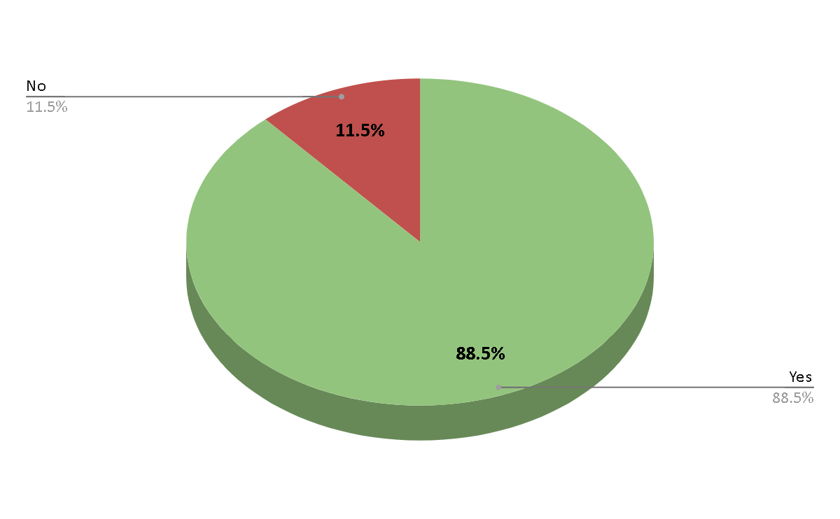

( See Table 6.1.2 , Page number :-71 )

* The above Pie chart shows that percentage of Yes is 88.5% which greater than No.

3.1.3. Do you use cosmetics from Bobbi Brown and/or Rare Beauty?

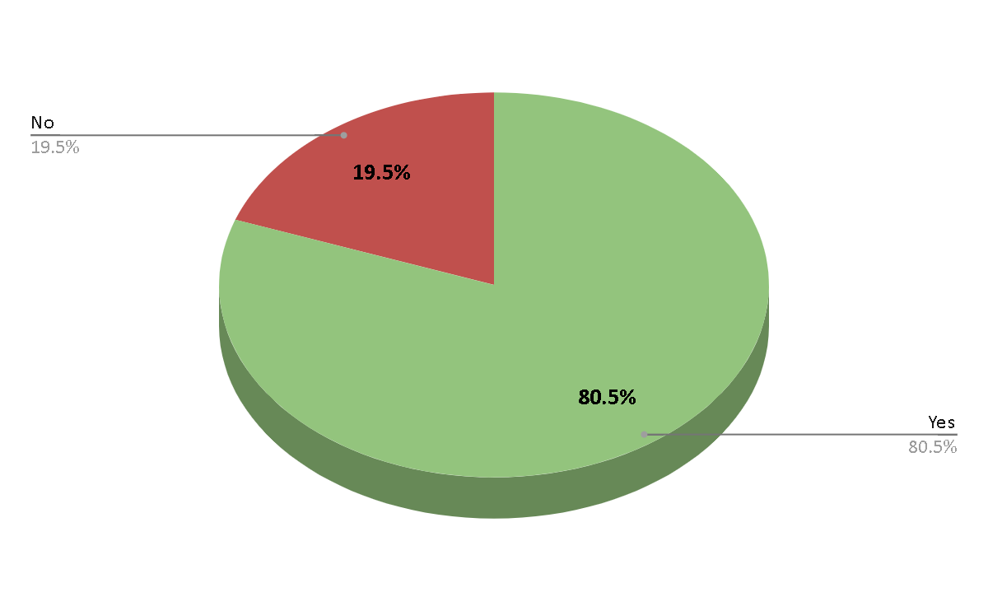

( See Table 6.1.3 , Page number :-71 )

* The above Pie Chart shows that percentage of Yes is 80.5% which greater than No.

For Users of Rare Beauty and/or Bobbi Brown.

3.1.4. Have you used beauty products from Rare Beauty and Bobbi Brown?

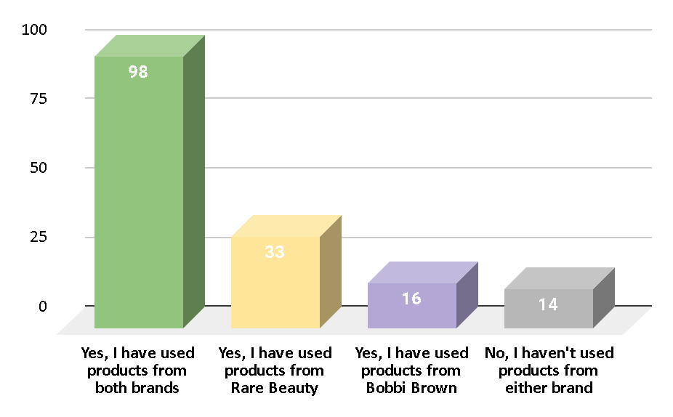

( See Table 6.1.4 , Page number ;-72)

* The above Column chart shows that number of respondents of

who used the both products is greater than single brand or who haven't used it.

3.1.5. Which brand do you prefer for makeup products?

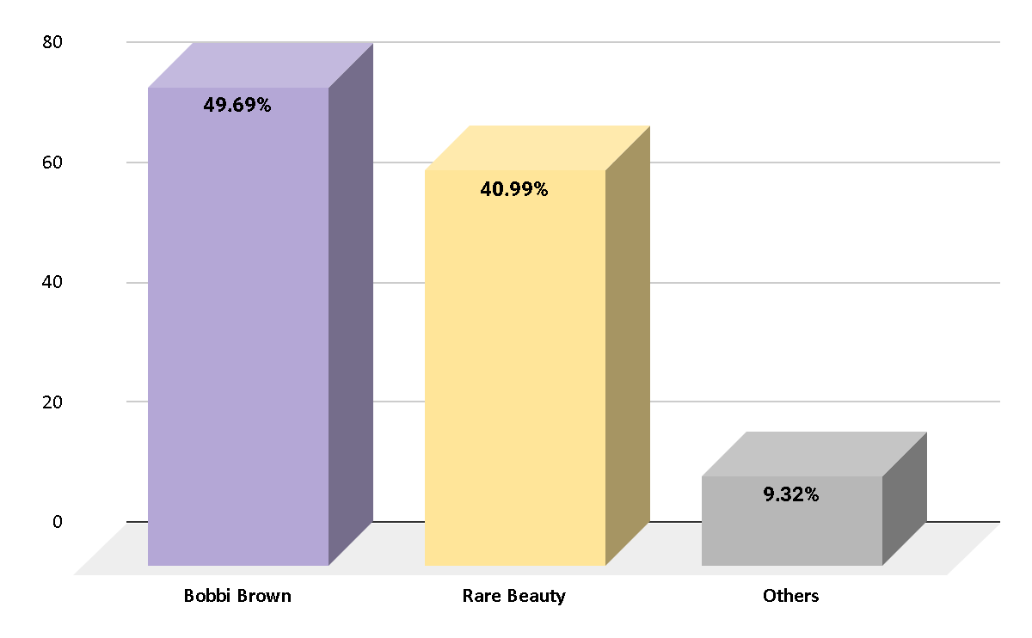

( See Table 6.1.5 , Page number:-72 )

* The above Column chart shows that Bobbi Brown is most preferable than Rare Beauty and others.

3.1.6. Which brand products do you think have a longer-lasting effect and better performance?

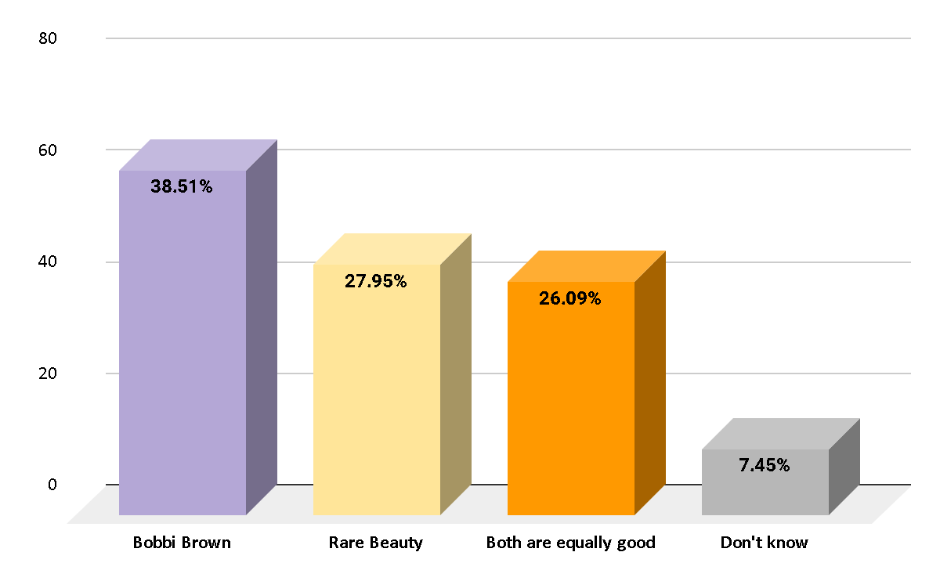

( See Table 6.1.6 , Page number :-72)

* The above Column chart shows that Bobbi brown have a longer-lasting effect and better performance.

3.1.7. Which brand products are more affordable?

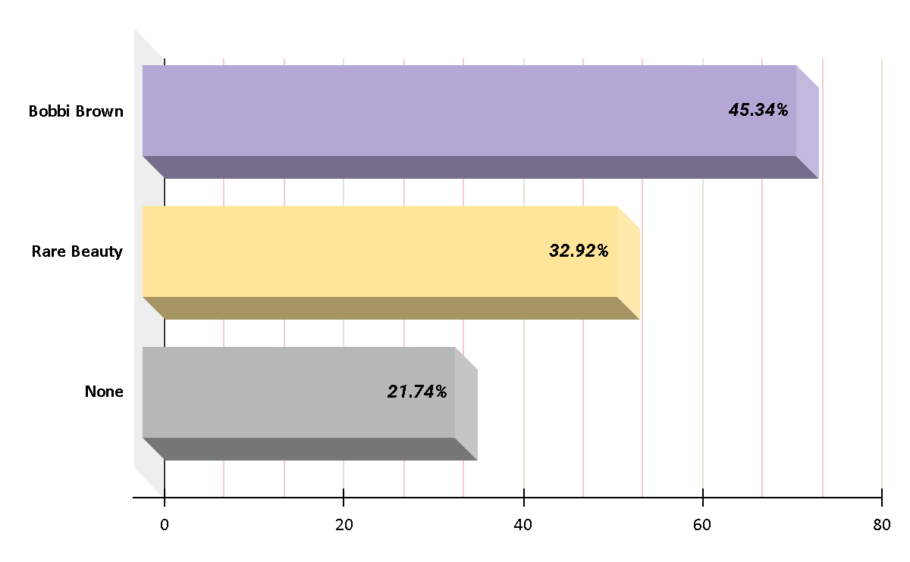

( See Table 6.1.7 , Page number :-73)

* The above Bar chart shows that Bobbi brown products are more affordable.

3.1.8. Is Bobbi Brown foundation better than Rare Beauty?

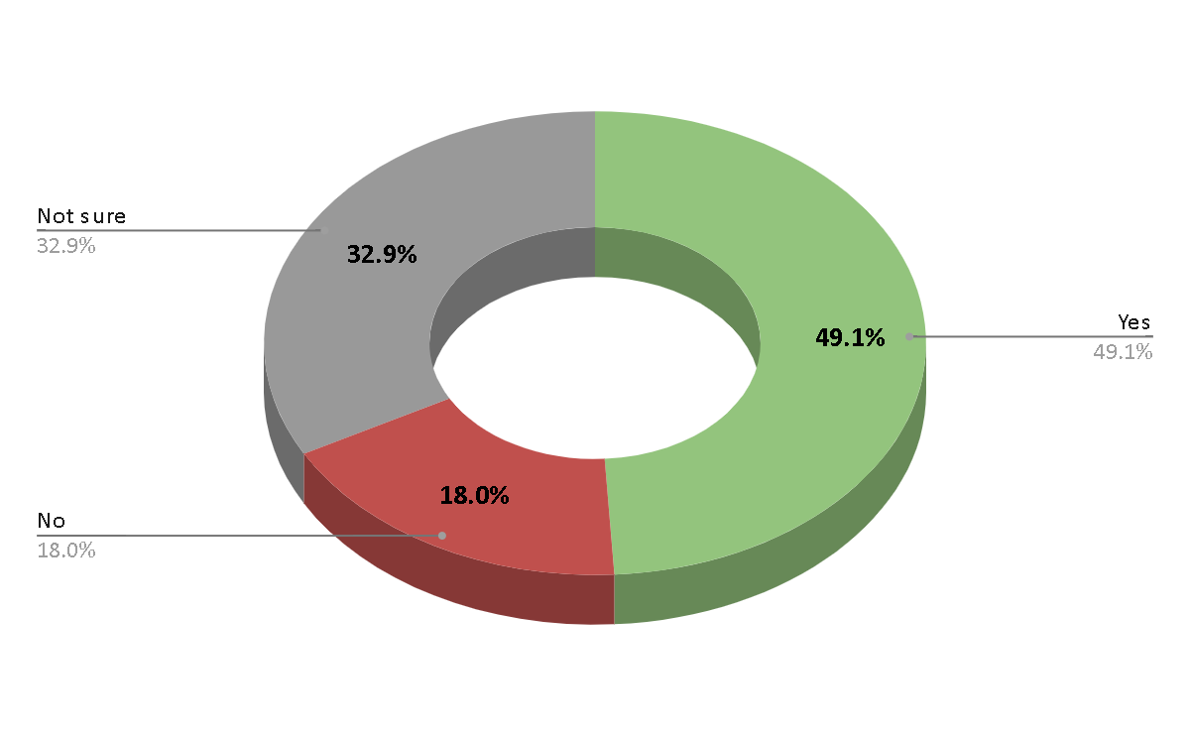

( See Table 6.1.8 , Page number:-73 )

* The above Donut chart shows the percentage of Yes is more. Hence, Bobbi Brown foundation better than Rare Beauty.

3.1.9. Is Rare Beauty lipstick long lasting than Bobbi Brown?

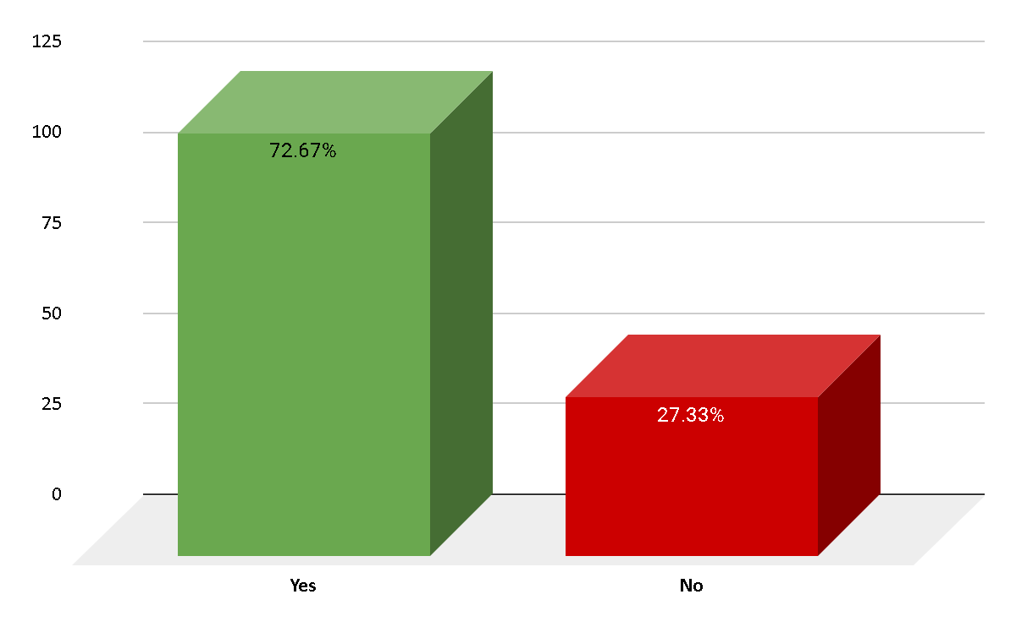

( See Table 6.1.9 , Page number :-73 )

* The above Column chart shows the percentage of Yes is more. Hence, Bobbi Brown foundation better than Rare Beauty.

3.1.10. Do these two brands have Sun Protection Factor in their products?

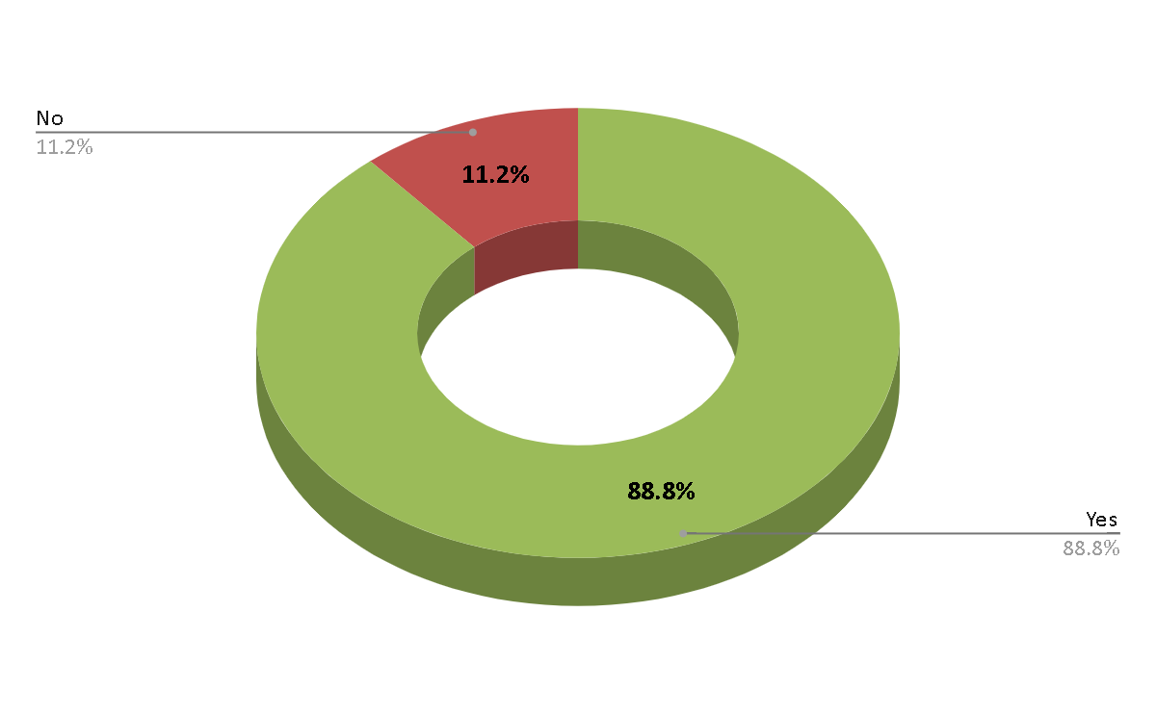

( See Table 6.1.10 , Page number :-73 )

* The above Donut chart shows that the percentage of Yes is more than No. Hence, these two brands have Sun Protection Factor in their products.

3.1.11. Which brand products are waterproof, sweatproof and transfer resistant?

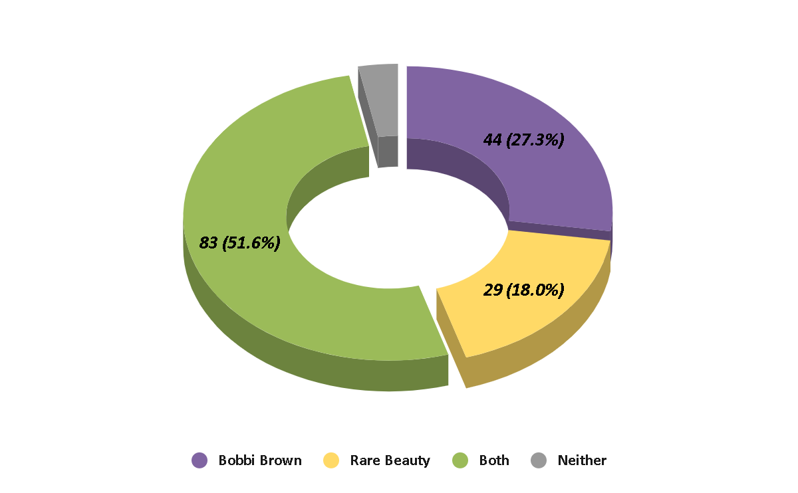

( See Table 6.1.11 , Page number :-74)

* The above Donut chart shows that the percentage of Both is greater. So, brand products are waterproof, sweatproof and transfer resistant.

3.1.12. What is the most selling product from these two brands?

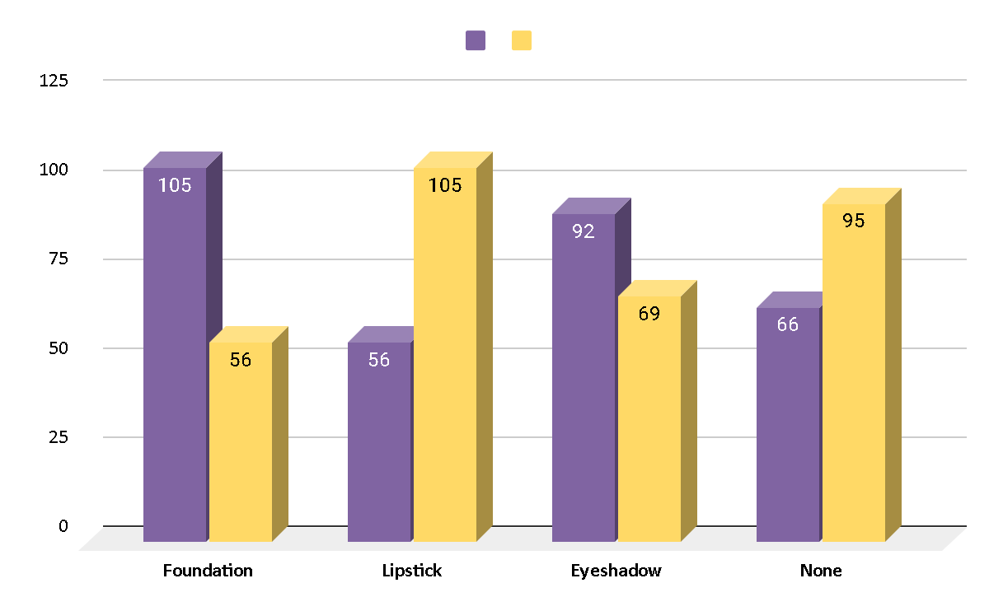

( See Table 6.1.12 , Page number :-74)

* The above Bar chart shows that from Bobbi Brown, Foundation and Eyeshadow, and from Rare Beauty, Lipstick is the most selling product.

3.1.13. If price were not a consideration, how likely or unlikely are you to purchase products from these brands?

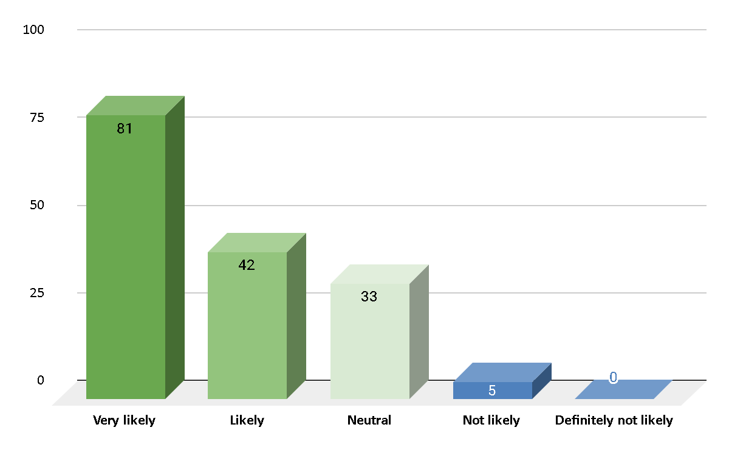

( See Table 6.1.13 , Page number :-74)

* The above Column chart shows that, If price were not a consideration they are very likely.

3.1.14. Which brand  products are you more likely to use in the future?

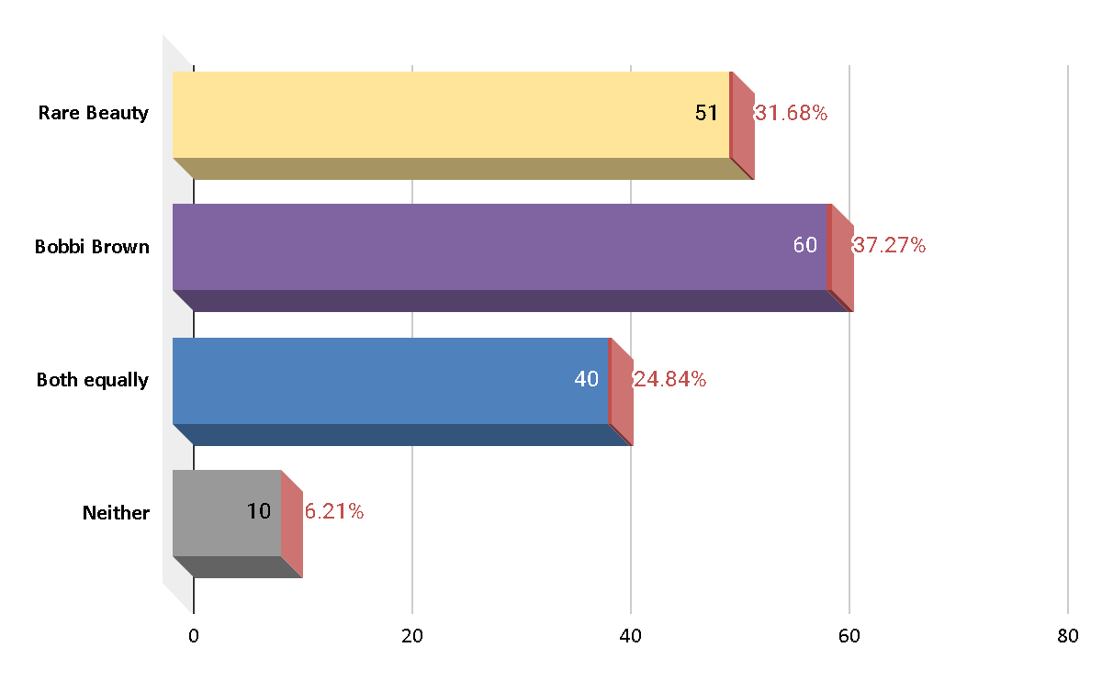

( See Table 6.1.14 , Page number :-75)

* The above Bar chart shows that Bobbi Brown brand  products are you more likely to use in the future.

3.1.15. What would be the main factor influencing your choice of future product usage?

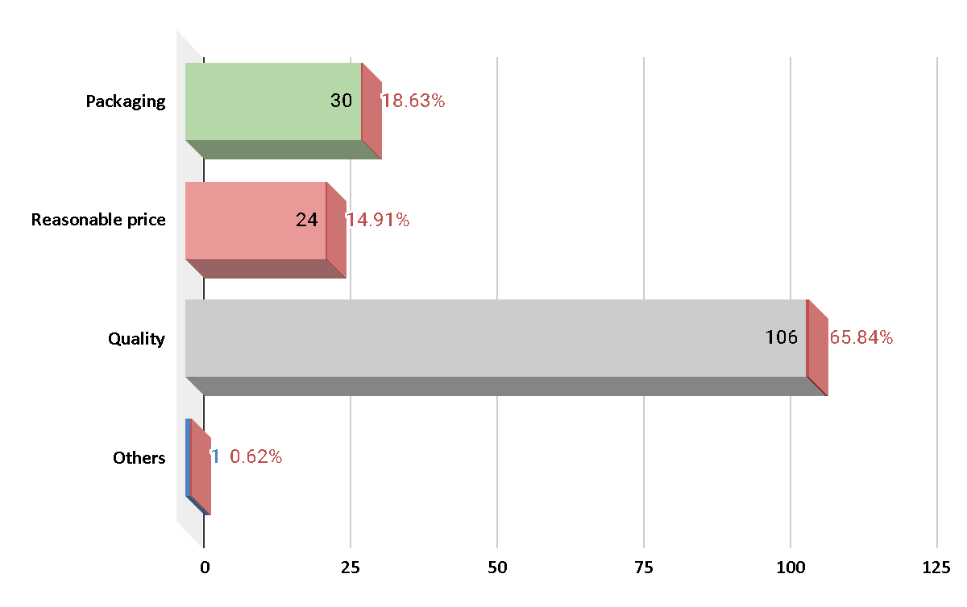

( See Table 6.1.15 , Page number :-75)

* The above Bar chart shows that Quality would be the main factor influencing your choice of future product usage.

3.1.16. Which specific type of product are you more likely to consider for future usage from your preferred brand?

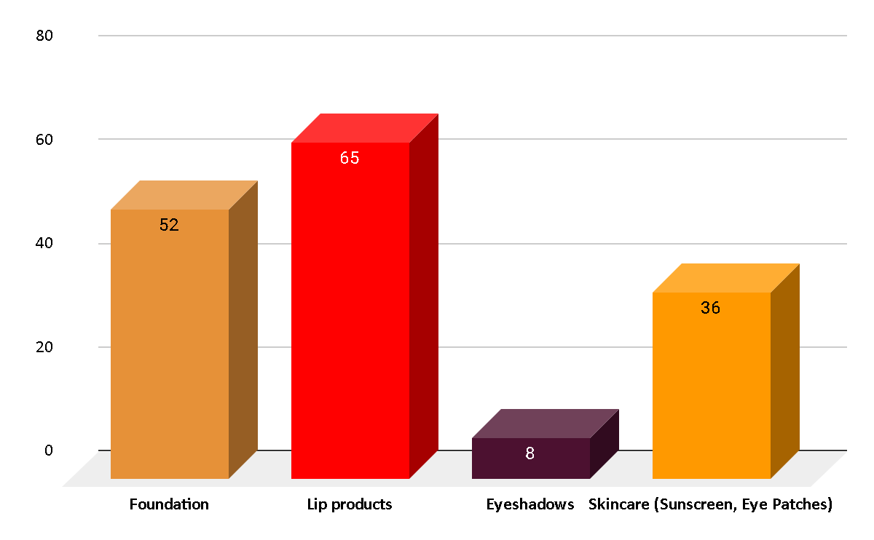

( See Table 6.1.16 , Page number:-75 )

* The above Column chart shows that Lip products is specific type of product are you more likely to consider for future usage from your preferred brand.

3.1.17. If you were to purchase a product within the next month, which brand would you lean towards?

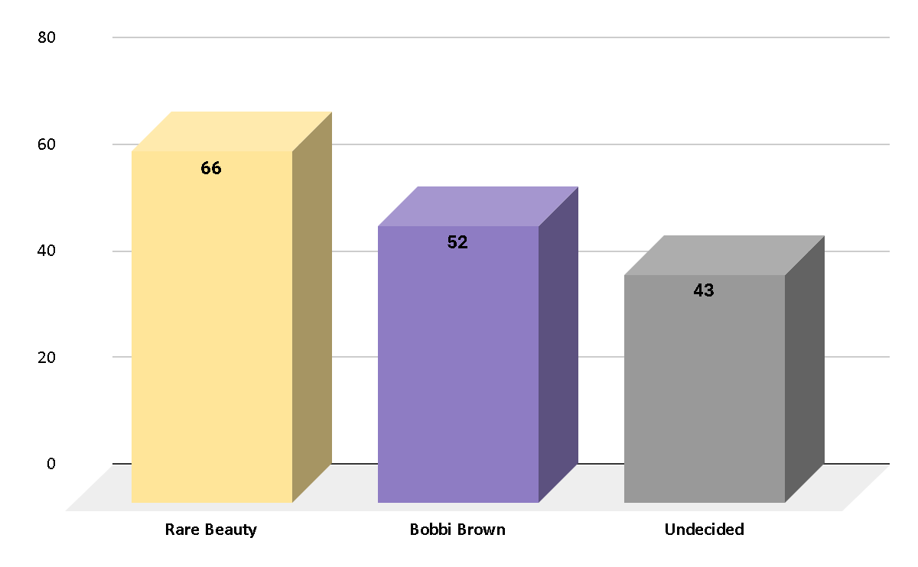

( See Table 6.1.17 , Page number :-76)

* The above Column chart shows that Rare Beauty would to purchase a product with in next month.

3.1.18. If you choose a preferred brand for future usage, what influenced your decision the most?

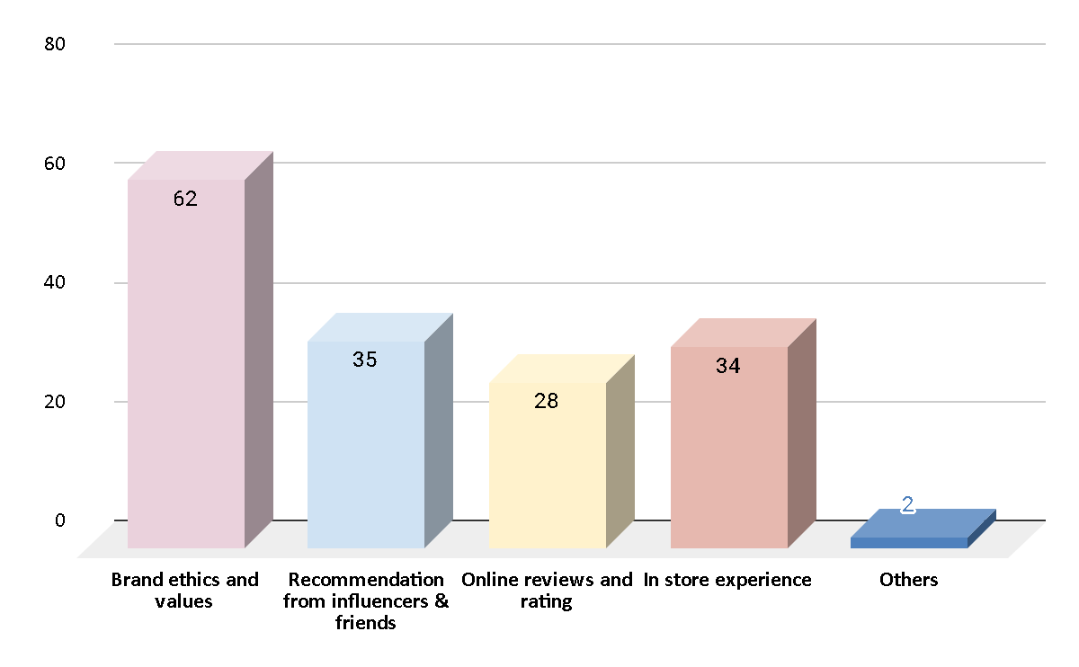

( See Table 6.1.18 , Page number :-76)

* The above Column chart shows that Brand ethics and values is Influenced the decision the most.

3.1.19. What beauty products are you willing to buy at high prices?

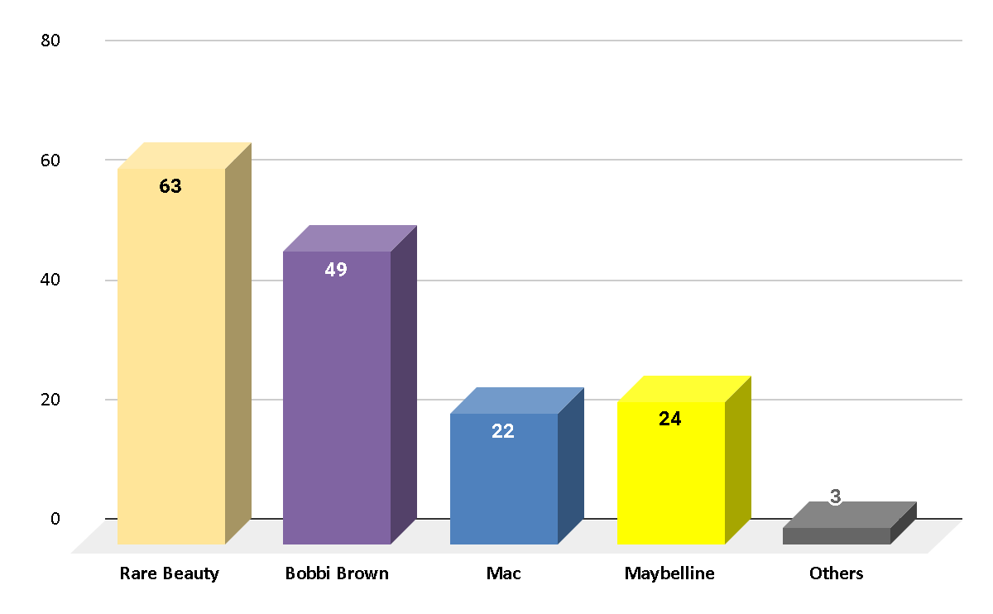

( See Table 6.1.19 , Page number:-76 )

* The above Column chart shows that Rare Beauty is the product that buyers are willing to buy at high prices.

3.1.20. What changes would you like to see in both Rare beauty & Bobbi brown products?

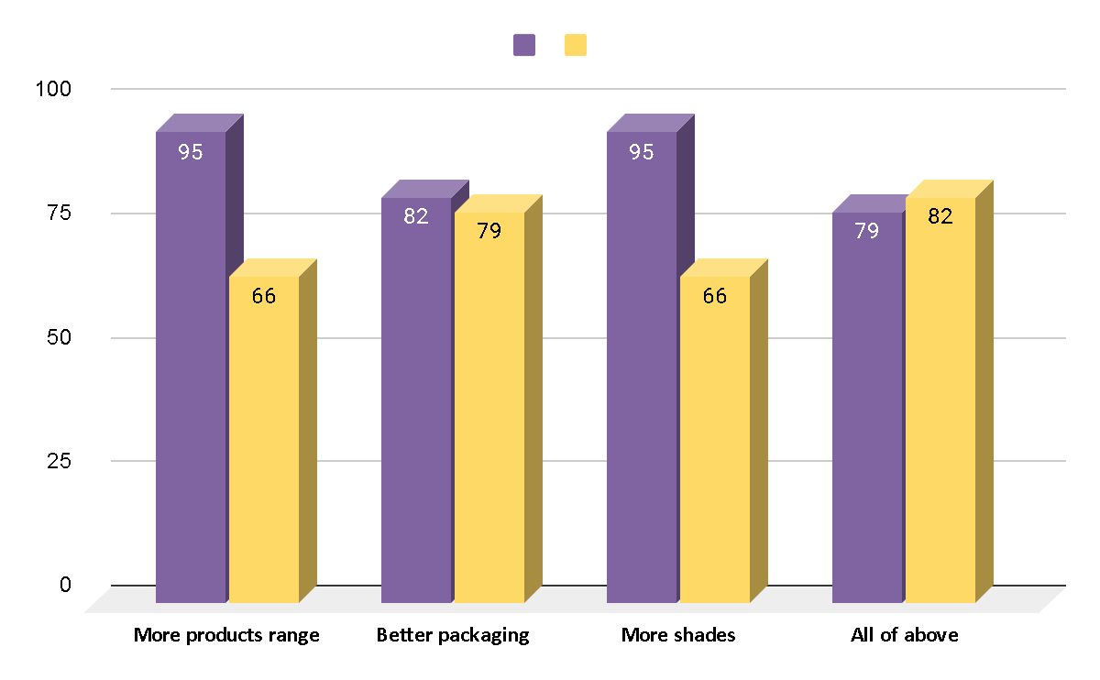

( See Table 6.1.20 , Page number:-77 )

* The above Column chart shows that from the Bobbi Brown Rare Beauty all of above would like to see .

For Non-users of Rare Beauty and Bobbi Brown.

3.1.21. Do you use any other Cosmetic brand?

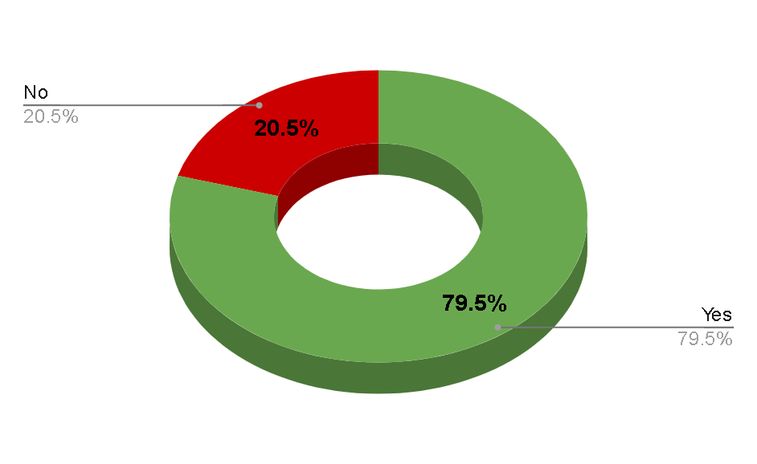

( See Table 6.1.21 , Page number:-77 )

* The above Donut chart shows that use of any other Cosmetic brand is more as see number of Yes are 79.5%.

3.1.22. Which Cosmetics brands you are using other than Rare Beauty and Bobbi Brown?

There is no graph for the corresponding data because it is an open-

ended question.

3.1.23. From where do you prefer to buy these Cosmetics?

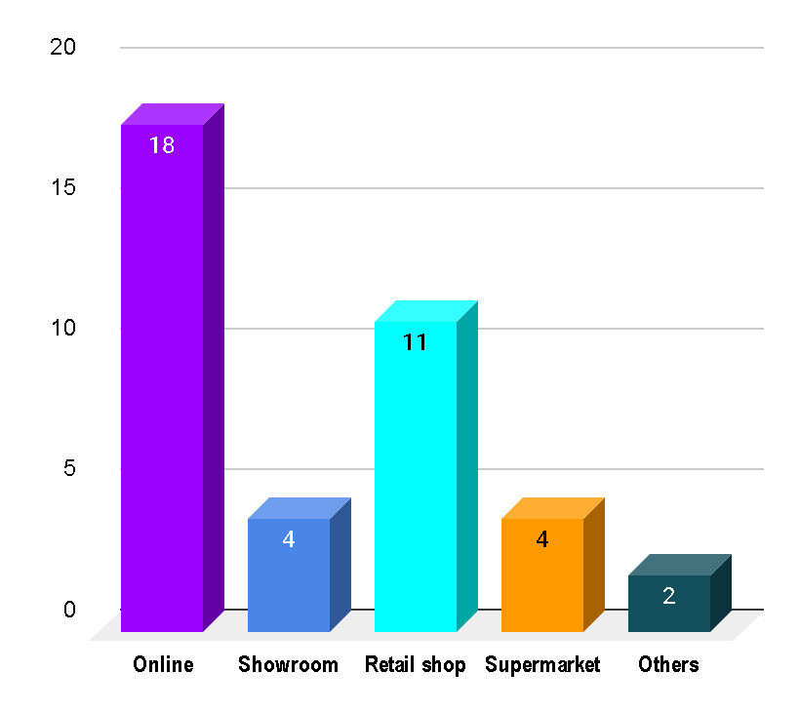

( See Table 6.1.23 , Page number:-78 )

* The above Column chart shows that they prefer to buy mostly from Online.

3.1.24. What type of cosmetics products you prefer to purchase?

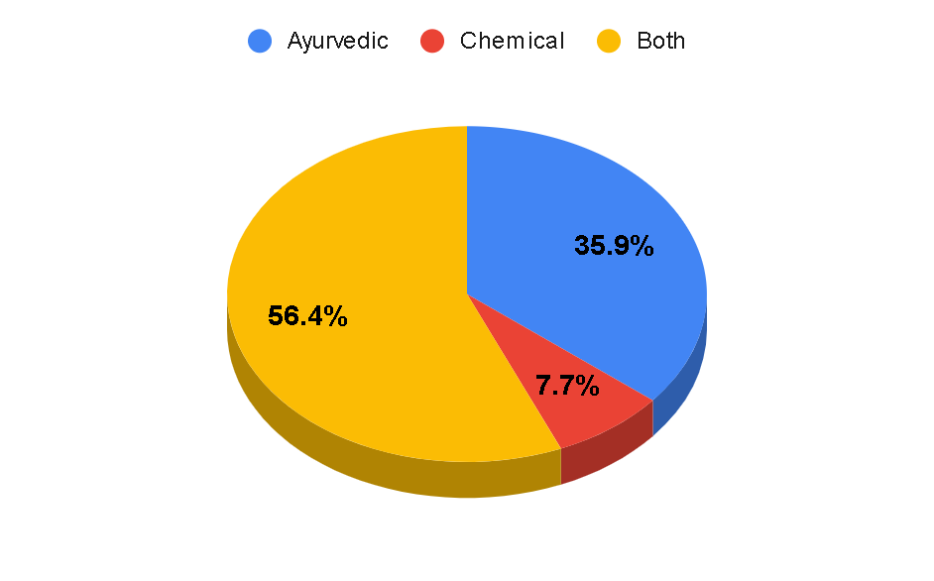

( See Table 6.1.24 , Page number :-78)

* The above Pie chart shows that they use Both type of products mainly.

3.1.25. Do you prefer international products more than local products?

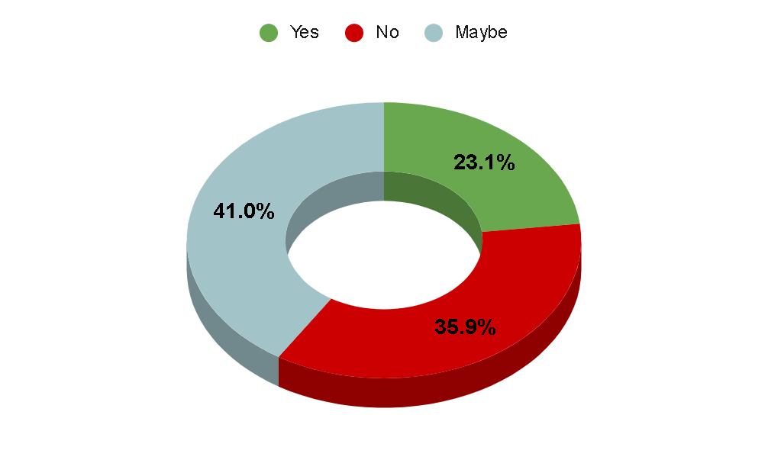

( See Table 6.1.25 , Page number:-78 )

* The above Donut chart shows that they maybe prefer international products more than local products.

3.1.26. Would you like to continue your current brands even if there is increase in 10-15%  or above in price?

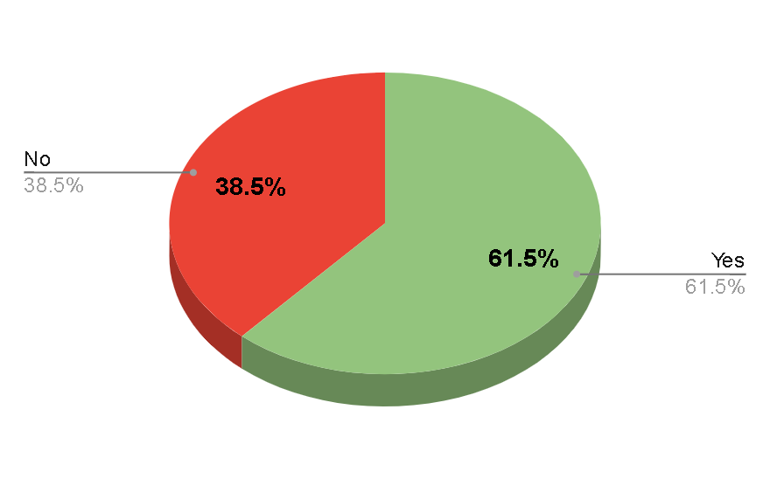

( See Table 6.1.26 , Page number:-79 )

* The above Pie chart shows that they like to continue your current brands even if there is increase in 10-15%  or above in price as seems percentage of Yes is Greater.

3.1.27. Reasons for not using Bobbi Brown Cosmetics?

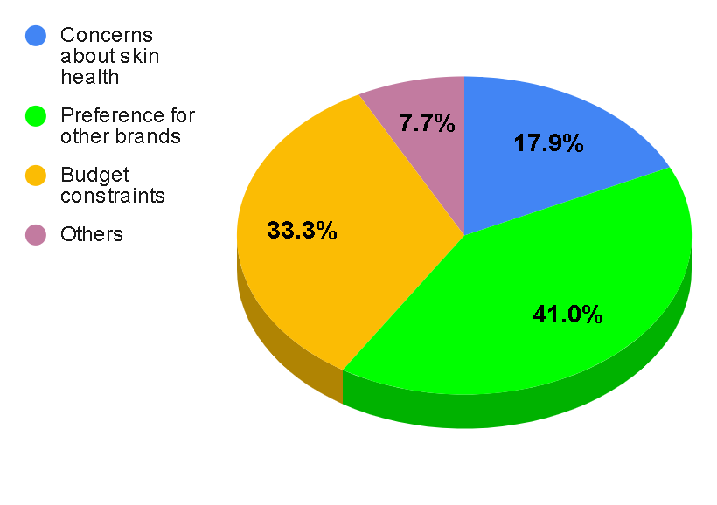

( See Table 6.1.27 , Page number :79)

3.1.28. What can be a reason for not choosing Rare Beauty Cosmetics?

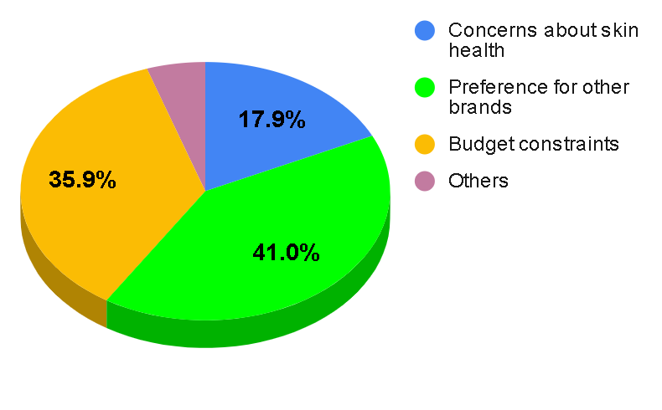

( See Table 6.1.28 , Page number :-79)

* The above Pie chart shows that the foremost reason for not choosing Rare Beauty is Preference for other brands and Budget constraints also.

3.1.29. Can you share any alternatives that you prefer over Bobbi Brown or Rare Beauty?

There is no graph for the corresponding data because it is an open-

ended question.

3.1.30. Would you reconsider using Bobbi Brown or Rare Beauty cosmetics in the future?

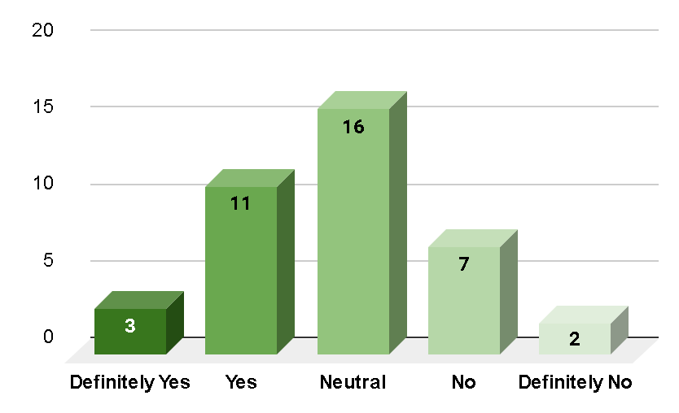

( See Table 6.1.30 , Page number:-80)

* The above Column chart shows that they are Netural towards reconsider using Bobbi Brown or Rare Beauty cosmetics in the future.

3.1.31. Have your friends or family members shared their opinions or experiences with Bobbi Brown and Rare Beauty brands that influence your choice?

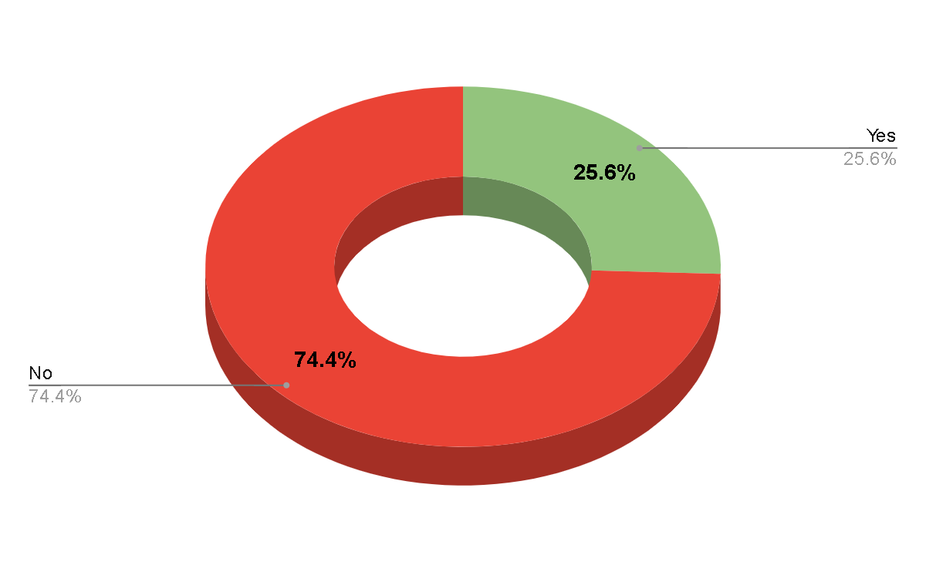

( See Table 6.1.31 , Page number :-80)

* The above Donut chart shows that they mostly shared their opinions or experiences with Bobbi Brown and Rare Beauty brands.

3.1.32. Have you ever had any experiences, positive or negative, with Bobbi Brown or Rare Beauty Cosmetics that influenced your decisions?

There is no graph for the corresponding data because it is an open-ended question.

Personal Data Of Respondents.

3.1.33. Name

There is no graph for the corresponding data because it is an open-

ended question.

3.1.34. Contact Number

There is no graph for the corresponding data because it is an open-

ended question.

3.1.35. Area of Residence

There is no graph for the corresponding data because it is an open-

ended question.

3.1.36. Age

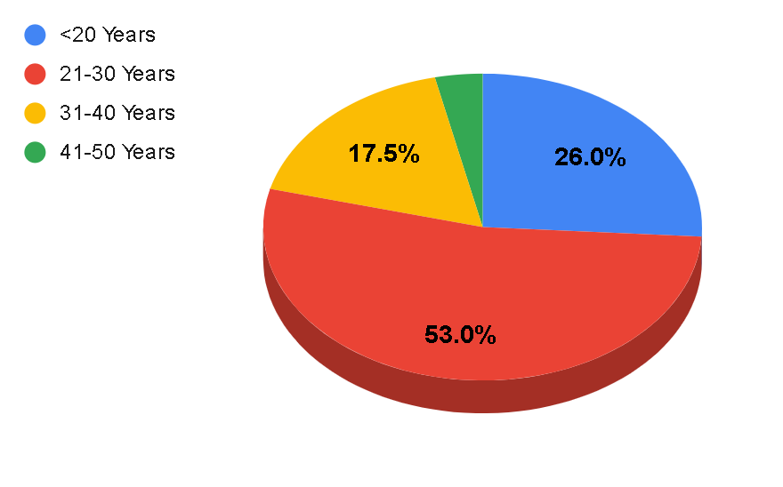

( See Table 6.1.36 , Page number 81)

* The above Pie chart shows that at the age of 21-30 Years is fill the Questionnaire the most( 53%).

3.1.37. Education

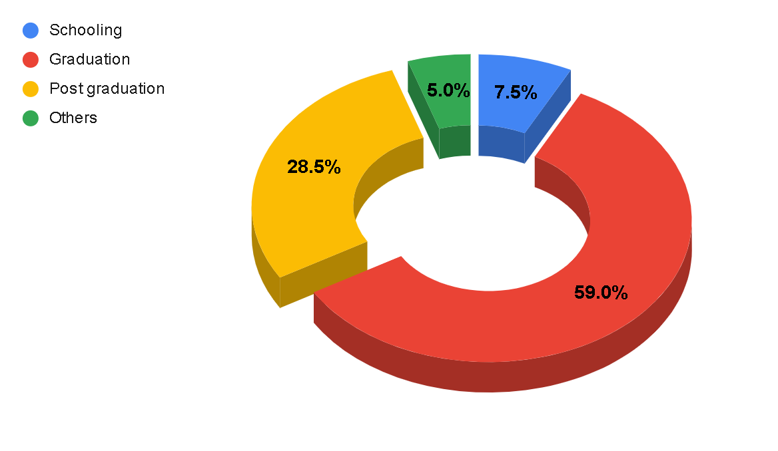

( See Table 6.1.37 , Page number :-81)

* The above Donut chart shows that those who fill survey is most from Gradution background(59%).

3.1.38. Occupation

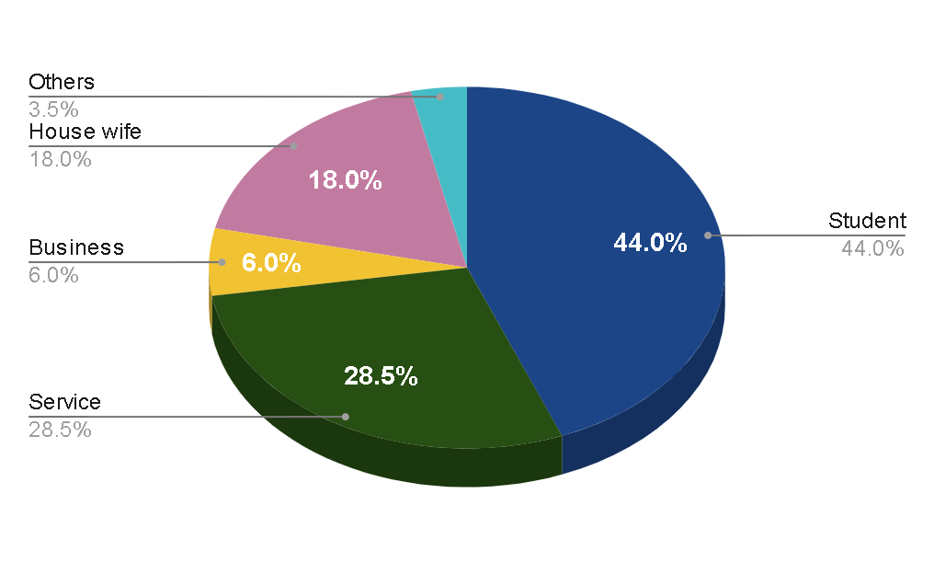

( See Table 6.1.38 , Page number:-82 )

* The above Pie chart shows that those who fill survey is mostly are Students.

3.1.39. Annual Income (In Rs.)

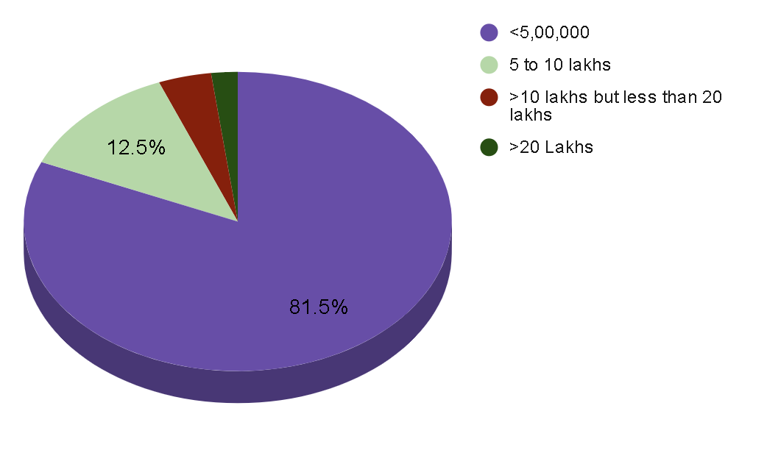

( See Table 6.1.39 , Page number:-82 )

* The above Pie chart shows that those who fill survey is most of have less than 5 lakhs Income earning per annum.

**3.2 Findings and Analysis of Primary Objectives:**

**3.2.1 (Hypothesis – 1:- One-way ANOVA)**

Null: There is no significant difference in likelihood to purchase products from Rare Beauty

and Bobbi Brown, not considering price, between the four income groups of respondents.

Alternative: There is a significant difference in likelihood to purchase products from Rare

Beauty and Bobbi Brown, not considering price, between the four income groups of

respondents

Why One-way ANOVA is conducted?

* When you have collected data about one categorical independent variable and one quantitative dependent variable.
* It is used when interrelationship of two variables on a dependent variable

At what level of significance?

* One-way ANOVA is conducted at a confidence level of 95%.

| **Descriptive Table** | | | | | | | | |
| --- | --- | --- | --- | --- | --- | --- | --- | --- |
| Consider | | | | | | | | |
|  | N | Mean | Std. Deviation | Std. Error | 95% Confidence Interval for Mean | | Minimum | Maximum |
| Lower Bound | Upper Bound |
| <5,00,000 | 123 | 1.74 | 0.867 | 0.075 | 1.6 | 1.89 | 1 | 4 |
| 5 to 10 lakhs | 20 | 1.7 | 0.865 | 0.193 | 1.3 | 2.1 | 1 | 3 |
| > 10 lakhs but less than 20 lakhs | 6 | 2.17 | 0.963 | 0.401 | 1.13 | 3.2 | 1 | 3 |
| > 20 lakhs | 2 | 2.5 | 2.121 | 1.5 | -16.56 | 21.56 | 1 | 4 |
| **Total** | 161 | 1.76 | 0.884 | 0.07 | 1.63 | 1.9 | 1 | 4 |

( Table 3.2.1.1)

It is used to analyze the data.

| **Tests of Homogeneity of Variance Table** | | | | | |
| --- | --- | --- | --- | --- | --- |
|  |  | Levene Statistic | df1 | df2 | Sig. |
| Consider | Based on Mean | 2.167 | 3 | 157 | 0.094 |
| Based on Median | 0.556 | 3 | 157 | 0.645 |
| Based on Median and with adjusted df | 0.556 | 3 | 153.926 | 0.645 |
| Based on trimmed mean | 2.113 | 3 | 157 | 0.101 |

( Table 3.2.1.2)

Tests of Homogeneity of Variances: - From this table, confidence level is 0.05. On the basis of the mean, significance value is 0.094, Significance level is more than 0.05. It means the NULL value is accepted and the alternative is rejected as there is relation between age and scope.

| **ANOVA Table** | | | | | |
| --- | --- | --- | --- | --- | --- |
| Consider | | | | | |
|  | Sum of Squares | df | Mean of Squares | F | Sig. |
| Between Groups | 2.189 | 3 | 0.73 | 0.933 | 0.426 |
| Within Groups | 122.842 | 157 | 0.782 |  |  |
| **Total** | 125.031 | 160 |  |  |  |

( Table 3.2.1.3)

ANOVA: From this table, on the basis of between income groups, significance value is 0.426, NULL value is accepted and the alternative is rejected.

**Levene’s statistics**

| **Multiple Comparison** | | | | | | | |
| --- | --- | --- | --- | --- | --- | --- | --- |
| **Dependent Variable: Consideration** | | | | | | | |
|  | (I)Income | (J)Income | Mean Difference (I-J) | Std. Error | Sig. | 95% Confidence Interval | |
| Lower Bound | Upper Bound |
| Tokey HSD | <5,00,000 | 5 to 10 lakhs | 0.044 | 0.212 | 0.997 | -0.51 | 0.6 |
| >10 lakhs but less than 20 lakhs | -0.422 | 0.369 | 0.663 | -1.38 | 0.54 |
| >20 lakhs | -0.756 | 0.63 | 0.628 | -2.39 | 0.88 |
| 5 to 10 lakhs | <5,00,000 | -0.044 | 0.212 | 0.997 | -0.6 | 0.51 |
| >10 lakhs but less than 20 lakhs | -0.467 | 0.412 | 0.669 | -1.54 | 0.6 |
| >20 lakhs | -0.8 | 0.656 | 0.615 | -2.5 | 0.9 |
| >10 lakhs but less than 20 lakhs | <5,00,000 | 0.422 | 0.369 | 0.663 | -0.54 | 1.38 |
| 5 to 10 lakhs | 0.467 | 0.412 | 0.669 | -0.6 | 1.54 |
| >20 lakhs | -0.333 | 0.722 | 0.967 | -2.21 | 1.54 |
| >20 lakhs | <5,00,000 | 0.756 | 0.63 | 0.628 | -0.88 | 2.39 |
| 5 to 10 lakhs | 0.8 | 0.656 | 0.615 | -0.9 | 2.5 |
| >10 lakhs but less than 20 lakhs | 0.333 | 0.722 | 0.967 | -1.54 | 2.21 |
| Games-Howell | <5,00,000 | 5 to 10 lakhs | 0.044 | 0.207 | 0.996 | -0.53 | 0.61 |
| >10 lakhs but less than 20 lakhs | -0.422 | 0.408 | 0.739 | -1.89 | 1.05 |
| >20 lakhs | -0.756 | 1.502 | 0.948 | -35.17 | 33.66 |
| 5 to 10 lakhs | <5,00,000 | -0.044 | 0.207 | 0.996 | -0.61 | 0.53 |
| >10 lakhs but less than 20 lakhs | -0.467 | 0.446 | 0.729 | -1.92 | 0.98 |
| >20 lakhs | -0.8 | 1.512 | 0.941 | -33.12 | 31.52 |
| >10 lakhs but less than 20 lakhs | <5,00,000 | 0.422 | 0.408 | 0.739 | -1.05 | 1.81 |
| 5 to 10 lakhs | 0.467 | 0.446 | 0.729 | -0.98 | 1.92 |
| >20 lakhs | -0.333 | 1.553 | 0.995 | -26.41 | 25.74 |
| >20 lakhs | <5,00,000 | 0.756 | 1.502 | 0.948 | -33.66 | 35.17 |
| 5 to 10 lakhs | 0.8 | 1.512 | 0.941 | -31.52 | 33.12 |
| >10 lakhs but less than 20 lakhs | 0.333 | 1.553 | 0.995 | -25.74 | 26.41 |

**3.2.2 (Hypothesis – 2:- Chi-Square Testof Association)**

(Chi-Square test of association – consider age below 30 as one group and

age above 30 as other group)

Null: There is no significant association between familiarity with beauty brands Rare Beauty

and Bobbi Brown and the age of respondents.

Alternative: There is a significant association between familiarity with beauty brands Rare

Beauty and Bobbi Brown and the age of respondents.

Why Chi-Square test is conducted?

* The purpose of this test is to determine if a difference between observed data and expected data is due to chance, or if it is due to a relationship between the variables you are studying.

At what level of significance?

* A significance level of 0.05 indicates a 5% risk of concluding that an association between the variables exists when there is no actual association.

| **Case Processing Summary Table** | | | | | | |
| --- | --- | --- | --- | --- | --- | --- |
|  | Valid | | Cases Missing | | Total | |
|  | N | Percent | N | Percent | N | Percent |
| consider*age | 197 | 98.50% | 3 | 1.50% | 200 | 100.00% |

( Table 3.2.2.1)

It is used to analyze the data.

| **consider*age Crosstabulation Table** | | | | | |
| --- | --- | --- | --- | --- | --- |
|  |  |  | age | | Total |
|  |  |  | <20,21-30 years | 31-40,41-50,<50 years |
| consider | yes | Count | 141 | 33 | 174 |
| % within consider | 81.00% | 19.00% | 100.00% |
| % within age | 91.60% | 76.70% | 88.30% |
| % of Total | 71.60% | 16.80% | 88.30% |
| no | Count | 13 | 10 | 23 |
| % within consider | 56.50% | 43.50% | 10.00% |
| % within age | 8.40% | 23.30% | 11.70% |
| % of Total | 6.60% | 5.10% | 11.70% |
| Total | | Count | 154 | 43 | 197 |
| % within consider | 78.20% | 21.80% | 100.00% |
| % within age | 100.00% | 100.00% | 100.00% |
| % of Total | 78.20% | 21.80% | 100.00% |

( Table 3.2.2.2)

It is used to analyze the data

]

| **Chi-Square Tests Table** | | | | | |
| --- | --- | --- | --- | --- | --- |
|  | Value | df | Asymptotic Significance (2-sided) | Exact Sig. (2-sided) | Exact Sig (1-sided) |
| Pearson Chi-Square | 7.154^a | 1 | 0.007 |  |  |
| Continuity Correction^b | 5.789 | 1 | 0.016 |  |  |
| Likelihood Ratio | 6.214 | 1 | 0.013 |  |  |
| Fisher's Exact Test |  |  |  | 0.014 | 0.014 |
| Linear-by-linear Association | 7.118 | 1 | 0.008 |  |  |
| N of Valid Cases | 197 |  |  |  |  |

( Table 3.2.2.3)

Therefore, at a significance level of 0.05, you can conclude that the association between the variables is statistically significant.

**CHAPTER – 4**

**RECOMMENDATIONS**

**AND CONCLUSION**

**4.1 Recommendation**

* packaging
* pigmented lipstick
* product quality
* attractive products
* Weightless makeup when we apply on skin
* Like foundation
* Inclusive variety of shades in rare beauty
* Rare beauty dermatologist tested
* Natural and real
* popular blush The wand applicator allows you to dispense the right amount of blush without getting messy and from there you can use your fingers, a brush or a sponge to blend it out.

**4.2 CONCLUSION**

Rare beauty

Rare Beauty aims to be inclusive by offering a diverse range of 48 foundation and concealer shades. The packaging is also made to be easy to use by people with disabilities with a sphere shape at the top of the applicators which prove to be disability-friendly.

Vegan and cruelty-free beauty brand, Rare Beauty was created by Selena Gomez and launched in September 2020, with a mission to celebrate individuality, redefine beauty standards and be a safe space for mental wellbeing.

Bobby brown

Bobbie brown have nailed it when it comes to formula. While I do enjoy matte lipsticks,they dry out my lips and smiling stretches the lips. This does not happen with these liquid lipsticks. They have an almost balm-y texture and feel light and moisturised on the lips.

Bobby brown lipstick Always free of parabens and mineral oils, our formulas are meticulously crafted to be safe, non-irritating, and uncompromising in their performance, wear, and care.

The Bobbi Brown Vitamin Enriched Face Base is a high-quality product that is definitely worth trying.

Vibrant color meets lush hydration in our moisturizing, long-lasting lipstick that swipes on a rich satin finish, 10-hour moisture, and 10-hour color-true wear.

**CHAPTER – 5**

**BIBLIOGRAPHY AND REFERENCES**

**Biblography**

<https://www.rarebeauty.com/>

<https://m.bobbibrown.in/>

<https://www.lookfantastic.com/brands/bobbi-brown.list>

<https://en.m.wikipedia.org/wiki/Rare_Beauty>

<https://en.m.wikipedia.org/wiki/Bobby_Brown>

<https://hbr.org/2014/10/bobbi-brown>

<https://www.vogue.in/topics/bobbi-brown>

**Reference**

<https://www.thepeacockmagazine.com/bobbi-brown>

<https://www.forbes.com/sites/valentinadidonato/2021/07/11/makeup-legend-bobbi-brown-stages-her-own-beauty-evolution/?sh=9d4af34ec5db>

<https://www.photobookmagazine.com/features/spring-beauty-launches-rare-beauty>

<https://www.vogue.in/content/exclusive-selena-gomez-brings-rare-beauty-to-india-vogue-chats-about-inclusivity-and-self-acceptance-through-beauty>

<https://www.fastcompany.com/90951624/selena-gomez-rare-beauty-cosmetics-industry-juggernaut-gen-z>

<https://www.elle.com/beauty/makeup-skin-care/a46084426/selena-gomez-rare-beauty-find-comfort-body-collection-interview/>

**CHAPTER – 6**

**Annexures**

**6.1 Annexures:**

6.1.1. Email

There is no table for the corresponding data because it is an open-

ended question.

6.1.2. Are you familiar with beauty brands Rare Beauty and Bobbi Brown?

| **Sr. No.** | **Options** | **No. of Respondents** | **Percentage** |
| --- | --- | --- | --- |
| 1 | Yes | 177 | 88.50% |
| 2 | No | 23 | 11.50% |
| **Total** | | 200 | 100.00% |

( See Graph 3.1.2 , Page number:-41 )

6.1.3. Do you use cosmetics from Bobbi Brown and/or Rare Beauty?

| **Sr. No.** | **Options** | **No. of Respondents** | **Percentage** |
| --- | --- | --- | --- |
| 1 | Yes | 161 | 80.50% |
| 2 | No | 39 | 19.50% |
| **Total** | | 200 | 100.00% |

( See Graph 3.1.3 , Page number :-41)

**FOR USERS OF RARE BEAUTY AND/OR BOBBI BROWN.**

6.1.4. Have you used beauty products from Rare Beauty and Bobbi Brown?

| **Sr. No.** | **Options** | **No. of Respondents** | **Percentage** |
| --- | --- | --- | --- |
| 1 | Yes, I have used products from both brands | 98 | 60.87% |
| 2 | Yes, I have used products from Rare Beauty | 33 | 20.50% |
| 3 | Yes, I have used products from Bobbi Brown | 16 | 9.94% |
| 4 | No, I haven't used products from either brand | 14 | 8.70% |
| **Total** | | 161 | 100.00% |

( See Graph 3.1.4 , Page number:-42 )

6.1.5. Which brand do you prefer for makeup products?

| **Sr. No.** | **Options** | **No. of Respondents** | **Percentage** |
| --- | --- | --- | --- |
| 1 | Bobbi Brown | 80 | 49.69% |
| 2 | Rare Beauty | 66 | 40.99% |
| 3 | Others | 15 | 9.32% |
| **Total** | | 161 | 100.00% |

( See Graph 3.1.5 , Page number :-42)

6.1.6. Which brand products do you think have a longer-lasting effect and better performance?

| **Sr. No.** | **Options** | **No. of Respondents** | **Percentage** |
| --- | --- | --- | --- |
| 1 | Bobbi Brown | 62 | 38.51% |
| 2 | Rare Beauty | 45 | 27.95% |
| 3 | Both are equally good | 42 | 26.09% |
| 4 | Don't know | 12 | 7.45% |
| **Total** | | 161 | 100.00% |

( See Graph 3.1.6 , Page number:-43 )

6.1.7. Which brand products are more affordable?

| **Sr. No.** | **Options** | **No. of Respondents** | **Percentage** |
| --- | --- | --- | --- |
| 1 | Bobbi Brown | 73 | 45.34% |
| 2 | Rare Beauty | 53 | 32.92% |
| 3 | None | 35 | 21.74% |
| **Total** | | 161 | 100.00% |

( See Graph 3.1.7 , Page number:-43)

6.1.8. Is Bobbi Brown foundation better than Rare Beauty?

| **Sr. No.** | **Options** | **No. of Respondents** | **Percentage** |
| --- | --- | --- | --- |
| 1 | Yes | 79 | 49.07% |
| 2 | No | 29 | 18.01% |
| 3 | Not sure | 53 | 32.92% |
| **Total** | | 161 | 100.00% |

( See Graph 3.1.8 , Page number :-44)

6.1.9. Is Rare Beauty lipstick long lasting than Bobbi Brown?

| **Sr. No.** | **Options** | **No. of Respondents** | **Percentage** |
| --- | --- | --- | --- |
| 1 | Yes | 117 | 72.67% |
| 2 | No | 44 | 27.33% |
| **Total** | | 161 | 100.00% |

( See Graph 3.1.9 , Page number :-44)

6.1.10. Do these two brands have Sun Protection Factor in their products?

| **Sr. No.** | **Options** | **No. of Respondents** | **Percentage** |
| --- | --- | --- | --- |
| 1 | Yes | 143 | 88.82% |
| 2 | No | 18 | 11.18% |
| **Total** | | 161 | 100.00% |

( See Graph 3.1.10 , Page number :-45)

6.1.11. Which brand products are waterproof, sweatproof and transfer resistant?

| **Sr. No.** | **Options** | **No. of Respondents** | **Percentage** |
| --- | --- | --- | --- |
| 1 | Bobbi Brown | 44 | 27.33% |
| 2 | Rare Beauty | 29 | 18.01% |
| 3 | Both | 83 | 51.55% |
| 4 | Neither | 5 | 3.11% |
| **Total** | | 161 | 100.00% |

( See Graph 3.1.11 , Page number:-45 )

6.1.12. What is the most selling product from these two brands?

| **Sr. No.** | **Options** | **No. of Respondents** | | **Total** |
| --- | --- | --- | --- | --- |
| **Bobbi Brown** | **Rare Beauty** |
| 1 | Foundation | 105 | 56 | 161 |
| 2 | Lipstick | 56 | 105 | 161 |
| 3 | Eyeshadow | 92 | 69 | 161 |
| 4 | None | 66 | 95 | 161 |
| **Total** | | 319 | 325 | 644 |
| **Percentage** | | 49.53% | 50.47% | 100.00% |

( See Graph 3.1.12 , Page number :-46)

)6.1.13. If price were not a consideration, how likely or unlikely are you to purchase products from these brands?

| **Sr. No.** | **Options** | **No. of Respondents** | **Percentage** |
| --- | --- | --- | --- |
| 1 | Very likely | 81 | 50.31% |
| 2 | Likely | 42 | 26.09% |
| 3 | Neutral | 33 | 20.50% |
| 4 | Not likely | 5 | 3.11% |
| 5 | Definitely not likely | 0 | 0.00% |
| **Total** | | 161 | 100.00% |

( See Graph 3.1.13 , Page number :-46)

6.1.14. Which brand  products are you more likely to use in the future?

| **Sr. No.** | **Options** | **No. of Respondents** | **Percentage** |
| --- | --- | --- | --- |
| 1 | Rare Beauty | 51 | 31.68% |
| 2 | Bobbi Brown | 60 | 37.27% |
| 3 | Both equally | 40 | 24.84% |
| 4 | Neither | 10 | 6.21% |
| **Total** | | 161 | 100.00% |

( See Graph 3.1.14 , Page number :-47)

6.1.15. What would be the main factor influencing your choice of future product usage?

| **Sr. No.** | **Options** | **No. of Respondents** | **Percentage** |
| --- | --- | --- | --- |
| 1 | Packaging | 30 | 18.63% |
| 2 | Reasonable price | 24 | 14.91% |
| 3 | Quality | 106 | 65.84% |
| 4 | Others | 1 | 0.62% |
| **Total** | | 161 | 100.00% |

( See Graph 3.1.15 , Page number:-47)

6.1.16. Which specific type of product are you more likely to consider for future usage from your preferred brand?

| **Sr. No.** | **Options** | **No. of Respondents** | **Percentage** |
| --- | --- | --- | --- |
| 1 | Foundation | 52 | 32.30% |
| 2 | Lip products | 65 | 40.37% |
| 3 | Eyeshadows | 8 | 4.97% |
| 4 | Skincare (Sunscreen, Eye Patches) | 36 | 22.36% |
| **Total** | | 161 | 100.00% |

( See Graph 3.1.16 , Page number:-48 )

6.1.17. If you were to purchase a product within the next month, which brand would you lean towards?

| **Sr. No.** | **Options** | **No. of Respondents** | **Percentage** |
| --- | --- | --- | --- |
| 1 | Rare Beauty | 66 | 40.99% |
| 2 | Bobbi Brown | 52 | 32.30% |
| 3 | Undecided | 43 | 26.71% |
| **Total** | | 161 | 100.00% |

( See Graph 3.1.17 , Page number:-48 )

6.1.18. If you choose a preferred brand for future usage, what influenced your decision the most?

| **Sr. No.** | **Options** | **No. of Respondents** | **Percentage** |
| --- | --- | --- | --- |
| 1 | Brand ethics and values | 62 | 38.51% |
| 2 | Recommendation from influencers & friends | 35 | 21.74% |
| 3 | Online reviews and rating | 28 | 17.39% |
| 4 | In store experience | 34 | 21.12% |
| 5 | Others | 2 | 1.24% |
| **Total** | | 161 | 100.00% |

( See Graph 3.1.18 , Page number :-49)

6.1.19. What beauty products are you willing to buy at high prices?

| **Sr. No.** | **Options** | **No. of Respondents** | **Percentage** |
| --- | --- | --- | --- |
| 1 | Rare Beauty | 63 | 39.13% |
| 2 | Bobbi Brown | 49 | 30.43% |
| 3 | Mac | 22 | 13.66% |
| 4 | Maybelline | 24 | 14.91% |
| 5 | Others | 3 | 1.86% |
| **Total** | | 161 | 100.00% |

( See Graph 3.1.19 , Page number::-49 )

6.1.20. What changes would you like to see in both Rare beauty & Bobbi brown products?

| **Sr. No.** | **Options** | **No. of Respondents** | | **Total** |
| --- | --- | --- | --- | --- |
| **Bobbi Brown** | **Rare Beauty** |
| 1 | More products range | 95 | 66 | 161 |
| 2 | Better packaging | 82 | 79 | 161 |
| 3 | More shades | 95 | 66 | 161 |
| 4 | All of above | 79 | 82 | 161 |
| **Total** | | 351 | 293 | 644 |
| **Percentage** | | 54.50% | 45.50% | 100.00% |

( See Graph 3.1.20 , Page number:-50 )

**FOR NON-USERS OF RARE BEAUTY AND BOBBI BROWN.**

6.1.21. Do you use any other Cosmetic brand?

| **Sr. No.** | **Options** | **No. of Respondents** | **Percentage** |
| --- | --- | --- | --- |
| 1 | Yes | 31 | 79.49% |
| 2 | No | 8 | 20.51% |
| **Total** | | 39 | 100.00% |

( See Graph 3.1.21 , Page number:-50)

6.1.22. Which Cosmetics brands you are using other than Rare Beauty and Bobbi Brown?

There is no table for the corresponding data because it is an open-

ended question.

6.1.23. From where do you prefer to buy these Cosmetics?

| **Sr. No.** | **Options** | **No. of Respondents** | **Percentage** |
| --- | --- | --- | --- |
| 1 | Online | 18 | 46.15% |
| 2 | Showroom | 4 | 10.26% |
| 3 | Retail shop | 11 | 28.21% |
| 4 | Supermarket | 4 | 10.26% |
| 5 | Others | 2 | 5.13% |
| **Total** | | 39 | 100.00% |

( See Graph 3.1.23 , Page number:-51)

6.1.24. What type of cosmetics products you prefer to purchase?

| **Sr. No.** | **Options** | **No. of Respondents** | **Percentage** |
| --- | --- | --- | --- |
| 1 | Ayurvedic | 14 | 35.90% |
| 2 | Chemical | 3 | 7.69% |
| 3 | Both | 22 | 56.41% |
| **Total** | | 39 | 100.00% |

( See Graph 3.1.24 , Page number:-52 )

6.1.25. Do you prefer international products more than local products?

| **Sr. No.** | **Options** | **No. of Respondents** | **Percentage** |
| --- | --- | --- | --- |
| 1 | Yes | 9 | 23.08% |
| 2 | No | 14 | 35.90% |
| 3 | Maybe | 16 | 41.03% |
| **Total** | | 39 | 100.00% |

( See Graph 3.1.25 , Page number:-52 )

6.1.26. Would you like to continue your current brands even if there is increase in 10-15%  or above in price?

| **Sr. No.** | **Options** | **No. of Respondents** | **Percentage** |
| --- | --- | --- | --- |
| 1 | Yes | 24 | 61.54% |
| 2 | No | 15 | 38.46% |
| **Total** | | 39 | 100.00% |

( See Graph 3.1.26 , Page number :-53)

6.1.27. Reasons for not using Bobbi Brown Cosmetics?

| **Sr. No.** | **Options** | **No. of Respondents** | **Percentage** |
| --- | --- | --- | --- |
| 1 | Concerns about skin health | 7 | 17.95% |
| 2 | Preference for other brands | 16 | 41.03% |
| 3 | Budget constraints | 13 | 33.33% |
| 4 | Others | 3 | 7.69% |
| **Total** | | 39 | 100.00% |

( See Graph 3.1.27 , Page number:-53 )

6.1.28. What can be a reason for not choosing Rare Beauty Cosmetics?

| **Sr. No.** | **Options** | **No. of Respondents** | **Percentage** |
| --- | --- | --- | --- |
| 1 | Concerns about skin health | 7 | 17.95% |
| 2 | Preference for other brands | 16 | 41.03% |
| 3 | Budget constraints | 14 | 35.90% |
| 4 | Others | 2 | 5.13% |
| **Total** | | 39 | 100.00% |

( See Graph 3.1.28 , Page number:-54 )

6.1.29. Can you share any alternatives that you prefer over Bobbi Brown or Rare Beauty?

There is no table for the corresponding data because it is an open-

ended question.

6.1.30. Would you reconsider using Bobbi Brown or Rare Beauty cosmetics in the future?

| **Sr. No.** | **Options** | **No. of Respondents** | **Percentage** |
| --- | --- | --- | --- |
| 1 | Definitely Yes | 3 | 7.69% |
| 2 | Yes | 11 | 28.21% |
| 3 | Neutral | 16 | 41.03% |
| 4 | No | 7 | 17.95% |
| 5 | Definitely No | 2 | 5.13% |
| **Total** | | 39 | 100.00% |

( See Graph 3.1.30 , Page number :-55)

6.1.31. Have your friends or family members shared their opinions or experiences with Bobbi Brown and Rare Beauty brands that influence your choice?

| **Sr. No.** | **Options** | **No. of Respondents** | **Percentage** |
| --- | --- | --- | --- |
| 1 | Yes | 10 | 25.64% |
| 2 | No | 29 | 74.36% |
| **Total** | | 39 | 100.00% |

( See Graph 3.1.31 , Page number :-55)

6.1.32. Have you ever had any experiences, positive or negative, with Bobbi Brown or Rare Beauty Cosmetics that influenced your decisions?

There is no table for the corresponding data because it is an open-

ended question.

Personal Data Of Respondents.

6.1.33. Name

There is no table for the corresponding data because it is an open-

ended question.

6.1.34. Contact Number

There is no table for the corresponding data because it is an open-

ended question.

6.1.35. Area of Residence

There is no table for the corresponding data because it is an open-

ended question.

6.1.36. Age

| **Sr. No.** | **Options** | **No. of Respondents** | **Percentage** |
| --- | --- | --- | --- |
| 1 | <20 Years | 52 | 26.00% |
| 2 | 21-30 Years | 106 | 53.00% |
| 3 | 31-40 Years | 35 | 17.50% |
| 4 | 41-50 Years | 7 | 3.50% |
| 5 | >50 Years | 0 | 0.00% |
| **Total** | | 200 | 100.00% |

( See Graph 3.1.36 , Page number :-57)

6.1.37. Education

| **Sr. No.** | **Options** | **No. of Respondents** | **Percentage** |
| --- | --- | --- | --- |
| 1 | Schooling | 15 | 7.50% |
| 2 | Graduation | 118 | 59.00% |
| 3 | Post graduation | 57 | 28.50% |
| 4 | Others | 10 | 5.00% |
| **Total** | | 200 | 100.00% |

( See Graph 3.1.37 , Page number :-57)

6.1.38. Occupation

| **Sr. No.** | **Options** | **No. of Respondents** | **Percentage** |
| --- | --- | --- | --- |
| 1 | Student | 88 | 44.00% |
| 2 | Service | 57 | 28.50% |
| 3 | Business | 12 | 6.00% |
| 4 | House wife | 36 | 18.00% |
| 5 | Retired | 0 | 0.00% |
| 6 | Others | 7 | 3.50% |
| **Total** | | 200 | 100.00% |

( See Graph 3.1.38 , Page number :-58)

6.1.39. Annual Income (In Rs.)

| **Sr. No.** | **Options** | **No. of Respondents** | **Percentage** |
| --- | --- | --- | --- |
| 1 | <5,00,000 | 163 | 81.50% |
| 2 | 5 to 10 lakhs | 25 | 12.50% |
| 3 | >10 lakhs but less than 20 lakhs | 8 | 4.00% |
| 4 | >20 Lakhs | 4 | 2.00% |
| **Total** | | 200 | 100.00% |

( See Graph 3.1.39 , Page number :-58)

**QUESTIONAIRE**

**A COMPARISON OF INTERNATIONAL BEAUTY BRANDS –BOBBI BROWN AND RARE BEAUTY**

We are ﬁnal year students of SOM LALIT INSTITUTE OF BUSINESS ADMINISTRATION Working on a research for BOBBI BROWN & RARE BEAUTY. This questionnaire is part of the requirement. We would be very grateful if you could devote a few minutes of your time to ﬁll this questionnaire. This will be used for academic purpose only and the data will be kept conﬁdential.

NAME ROLL NO.

1. Bafna Vidhi 5
2. Bukhari RuheenFatema 11
3. Chaudhary Priyanka 13
4. Jain Twisha 46
5. Khandelwal Laxita 56

6. Khunti Nirali 58

7. Panchal Vaishnavi 87

8. Patel Khushi 102

1. Solanki Heena 141

10.Tiwari Suhani 154

1. Are you familiar with beauty brands Rare Beauty and Bobbi Brown?

* yes
* No

2. Do you use cosmetics from Bobbi Brown and/or Rare Beauty?

* Yes
* No

**FOR USERS OF RARE BEAUTY AND BOBBI BROWN:**

1.Have you used beauty products from Rare Beauty and Bobbi Brown?

* Yes , I have used products from both brands.
* Yes , I have used product from Rare beauty.
* Yes , I have used product from Bobbi brown.
* No , I haven’t used products from both brands

2. Which brand do you prefer for makeup products?

* Bobbi Brown
* Rare Beauty
* Other:

3. Which brand products do you think have a longer- lasting effect and better performance?

* Bobbi Brown
* Rare beauty
* Both are equally good
* Don’t know

4. Which brand products are more affordable?

* Bobbi brown
* Rare beauty
* None

5. Is Bobbi Brown foundation better than Rare Beauty?

* Yes
* No
* Not sure

6. Is Rare Beauty lipstick lasting than Bobbi Brown?

* Yes
* No

7. Do these two brands have Sun Protection Factor in their products?

* Yes
* No

8. Which brand products are waterproof, sweatproof and t ransfer resistant?

* Bobbi Brown
* Rare beauty
* Both
* Neither

9.What is the most selling product from these two brands?

|  | **Bobbi Brown** | **Rare Beauty** |
| --- | --- | --- |
| **Foundation** |  |  |
| **Lipstick** |  |  |
| **Eyeshow** |  |  |
| **none** |  |  |

10. If price were not a consideration, how likely or unlikely are you to purchase products from these brands?

* Very likely
* Likey
* Netural
* Not likely
* Definitely not likely

11.Which brand products are you more likely to use in the future?

* Rare beauty
* Bobbi brown
* Both equally
* neither

12. What would be the main factor influencing your choice of future product usage?

* Packaging
* Reasonable price
* Quality
* Other:

13. Which specific type of product are you more likely to consider for future usage

from your preferred brand?

* Foundation
* Lip products
* Eyeshadows
* Skincare(sunscreen Eye patches)

14. If you were to purchase a product within the next month, which brand would you lean towards?

* Rare Beauty
* Bobbi Brown
* Undecided

15. If you choose a preferred brand for future usage, what influenced your decision the most?

* Brand ethics and values
* Recommendation from inﬂuencers & friends
* Online reviews and rating
* In store experience
* Other:
  + - * 

16. What beauty products are you willing to buy at high prices?

* Rare Beauty
* Bobbi Brown
* Mac
* Maybelline
* Other:



17.What changes would you like to see in both Rare beauty & Bobbi brown products?

|  | **Bobbi Brown** | **Rare Beauty** |
| --- | --- | --- |
| **More product range** |  |  |
| **Better packaging** |  |  |
| **More shades** |  |  |
| **All of the a bove** |  |  |

**For Non- users of Rare Beauty and Bobbi Brown:**

1. Do you use any other Cosmetic brand?

* Yes
* No

2. Which Cosmetics brands you are using other than Rare Beauty and Bobbi Brown?



3. From where do you prefer to buy these Cosmetics?

* Online Showroom
* Retail shop
* Supermarket
* Other:



4. What type of cosmetics products you prefer to purchase?

* Ayurvedic
* Chemical
* Both

5. Do you prefer international products more than local products?

* Yes
* No
* Maybe

6. Would you like to continue your current brands even if there is increase in 10-15% or above in price?

* Yes
* No

7. Reasons for not using Bobbi Brown Cosmetics?

* Concerns about skin health
* Preference for other brands
* Budget constraints
* Other:



8. What can be a reason for not choosing Rare Beauty Cosmetics?

* Concerns about skin health
* Preference for other brands
* Budget constraints
* Other:



9. Can you share any alternatives that you prefer over Bobbi Brown or Rare Beauty?



10. Would you reconsider using Bobbi Brown or Rare Beauty cosmetics in the future?

* Deﬁnitely Yes
* Yes
* Neutral
* No
* Deﬁnitely No

11. Have your friends or family members shared their opinions or experiences with Bobbi Brownand Rare Beauty brands that influence your choice?

* Yes
* No

12. Have you ever had any experiences, positive or negative, with Bobbi Brown or Rare Beauty Cosmetics that influenced your decisions?



**PERSONAL DATA OF RESPONDENTS**

* Name
* Contact Number
* Area of Residence

AGE

* <20 Years
* 21- 30 Years
* 31- 40 Years
* 41- 50 Years
* >50 Years

EDUCATION

* Schooling
* Graduation
* Post graduation
* Other:



OCCUPATION

* Student
* Service
* Business
* House wife
* Retired
* Other:



ANNUAL INCOME (IN RS.)

* <5,00,000
* 5 to 10 lakhs
* >10 lakhs but less than 20 lakhs
* >20 Lakhs